A Deep Learning based Technique for Human Activity Recognition using
Accelerometer data from Sensor- based Smartphones

Final Year Project
Session 2022-2026

A project submitted in partial fulfillment of the degree of


BS in Software Engineering

Department of Software Engineering
Faculty of Computer Science & Information Technology
The Superior University, Lahore

Fall 2022

Type (Nature of project) |  | [ ] Development [ ] Research [ ] R&D
Area of specialization |  | Research
FYP ID |  | BSSEM-FYP-F25-060
Project Group Members
Sr.# | Reg. # | Student Name | Email ID | *Signature
(i) | Su92-bssem-f22-208 | M Awais | su92-bssem-f22-208@superior.edu.pk | M Awais
(ii) | Su92-bssem-f22-184 | Nida Munir | su92-bssem-f22-184@superior.edu.pk | Nida Munir

*The candidates confirm that the work submitted is ther own and appropriate credit has been given where reference has been made to work of others

Plagiarism Free Certificate
This is to certify that, I M Awais S/O of Muhammad Akbar , group leader of FYP under registration no Su92-bssem-f22-208 at Software Engineering Department, The Superior University, Lahore. I declare that my FYP report is checked by my supervisor.
Date:
Name of Group Leader: Muhammad Awais Signature: _____________
Name of Supervisor: Muhammad Sohail Co-Supervisor: Dr. H. M. Shahzad
Designation: Lecturer Designation: Assistant Professor
Signature: ________________ Signature: _________________

HOD: Muhammmad Aqeel
Signature: _______________

APPROVAL
Project Supervisor
Comments: ___________________________________________________________________
_____________________________________________________________________________
Name:______________________________
Date:_______________________________ | Signature:__________________________

Project Manager
Comments: ___________________________________________________________________
_____________________________________________________________________________
Date:_______________________________ | Signature:__________________________

Head of the Department
Comments: ___________________________________________________________________
_____________________________________________________________________________
Date:_______________________________ | Signature:__________________________

DEDICATION

This project is especially dedicated to the supervisor for the continual impact on my knowledge and who helped and guided me to work better. Additionally, I'd want to dedicate my thesis to my parents, teachers, and whole family, who have been fantastic supporters throughout my research and have been encouraging me to complete this project.

ACKNOWLEDGEMENT

With the guidance of my seniors I was able to successfully complete my dissertation. I am beyond grateful to each of them for their help.
Primarily, I would thank Allah Almighty, my creator, my strong pillar. Then I'll thank my supervisor, who guided and instructed me throughout this project and from whom I learnt a lot. Her suggestions and instructions have contributed to this success.
I also want to convey my sincere thanks to my family and my friends for their encouragement and support while I worked through the research work's various phases.
Finally, I would like to thank my university for allowing me the opportunity to finish this fantastic project on the subject of (A deep Learning based Technique for Human Activity Recognition using Accelerometer data from sensor-based smartphones). This university also assisted me in conducting extensive research, which allowed me to find out a lotof new information.

ABSTRACT

Human Activity Recognition (HAR) is a growing research area and playing a significant role in various applications to monitoring the human’s daily behavior such as healthcare, sports, smart home, behavioral analysis and fitness tracking. Additionally, Smart phones are frequently used in the current worldwide. Sensor-based smartphone use to get this kind of data from people to infer human physical activities. In this research, we are going to propose a deep learning approach for HAR using accelerometer data. The purpose of this research is to identify and classify six basic human activities: standing, sitting, walking, jogging and determining whether a person is ascending or descending stairs. This research focuses on the use of a Convolutional Neural Network (CNN), a deep learning approach, the accelerometer present in smartphones, to predict and categorize these actions accurately. Furthermore, the methodology proposed in this research focuses on classifying data into nodes, which are subsequently divided into three basic layers inside the CNN. Following this division, outcome prediction takes place at the output layer. Additionally, this work also contributes to the evaluation of the two-dimensional CNN model's testing and training. During the training phase, a model will be trained using motion signals and preprocessed procedures applied to a dataset. Afterwards, in the validation phase, unknown data will be passed to model and classify it in the respective class. Our goal is to put the proposed approach to the test and compare the findings to those of other strategies found in the literature. Finally, with a 95% accuracy rate, the model was able to predict the actions.

TABLE OF CONTENTS

Chapter 1: Introduction 1
  - What is Human Activity Recognition? 1
  - Technologies / Tools for HAR Recognition 2
  - Comparative Analysis of Sensors 4
  - Applications of HAR 5
  - Limitations of HAR 7
  - Statistics 8
  - Objective 9
  - Thesis Structure 9
Chapter 2: Literature Review 10
  - Notion of “Human Activity” 10
  - Human Activity Recognition Approaches 11
    - Vision Based 12
    - Sensor Based 13
  - Publically Available dataset for HAR 13
    - UCI-HAR Dataset 13
    - WISDM Dataset 14
    - Opportunity Dataset 14
    - PAMAP 2 Dataset 15
    - UniMib Shar Dataset 15
  - Data Acquisition 17
  - Data Preprocessing 19
  - Data Filtering 20
  - Data Cleaning 21
    - Missing Values 21
    - Noisy Data 21
  - Data Balancing 22
  - Data Integration 22
  - Data Segmentation 22
    - Activity-based Windowing 23
    - Event- based Windowing 23
    - Sliding windowing 24
  - Feature Extraction 24
    - Hand-Crafted Features 25
    - Learned Features 25
  - Evaluation Metrics for HAR system 26
  - Traditional Classification Algorithm and Techniques 27
    - Machine Learning Based Techniques 27
    - Support Vector Machine 27
    - Random Forest 29
    - K-Nearest Neighbor 30
    - Naive Bayes 31
  - Machine Learning for HAR 32
  - Deep Learning-Based Techniques 33
    - ANN 34
    - Convolutional Neural Network 35
    - LSTMs 37
  - Deep Learning for HAR 39
Chapter 3: Materials and Methods 50
  - Description of Dataset 50
  - Human Activity Labels 51
  - Accelerometer Reading 52
  - Pre-processing of data 56
    - Data Balancing 56
    - Data Uniformity 56
    - Overfitting Avoidance during training data 57
  - Data Standardization 59
  - Frame Preparation 60
  - Activity Recognition Algorithm 61
    - CNN for Human Activity Recognition 61
Chapter 4: Results and Discussion 64
  - Experimental Setup 64
  - Performance Evaluation Metrics 65
  - Data Splitting 65
  - Proposed Approach 66
    - The 2D CNN Model 66
  - Results and Discussion 69
  - Model Evaluation 69
  - Confusion Matrix 71
  - Comparison of proposed approach with other Techniques 72
Chapter 5: Conclusion 75
References: 76

LIST OF FIGURES

Figure 1-1 Basic Human Activity Recognition Outline 1
Figure 1-2 some technologies used for activity recognition 3
Figure 1-3 Applications of Human activity recognition 7
Figure 2-1 Examples of Action Based Activities 11
Figure 2-2 Classification of HAR Approaches 12
Figure 2-3 Steps of Data Preprocessing 20
Figure 2-4 Activity and Time based windows 23
Figure 2-5 Non-overlapping & Overlapping sliding window 24
Figure 2-6 Conventional & Automatic Feature Extraction 25
Figure 2-7 Support Vector Machine 28
Figure 2-8 Random Forest 30
Figure 2-9 K-Nearest Neighbor 31
Figure 2-10 Naïve Bayes 32
Figure 2-11 Artificial Neural Network 35
Figure 2-12 Structure of CNN 36
Figure 2-13 Long Short Term Memory 38
Figure 3-1 Example of WISDM dataset 51
Figure 3-2 User’s Training Examples 57
Figure 3-3 Examples of Training by Activity type 58
Figure 3-4 Balanced Number of training examples 58
Figure 3-5 CNN model development 62
Figure 4-1: Different layers of 2D CNN model 67
Figure 4-2: Graph illustrating model accuracy 70
Figure 4-3: Model loss detection graph 70
Figure 4-4: Confusion Matrix evaluated by proposed model 71

LIST OF TABLES
Table 1-1 Comparison of Sensors 5
Table 2-1 Publicly available datasets with various modalities 16
Table 2-2 Summarization of Evaluation metrics 27
Table 2-3 Review of Other Machine & Deep Learning Techniques 41
Table 3-1 Dataset 50
Table 3-2 Human Activity and their Labels 52
Table 3-3 Standardize Data 59
Table 3-4 Parameter values 60
Table 4-1 Experimental Setup 64
Table 4-2 Dataset before & after Reshaping 66
Table 4-3 Layer-wise Configuration of proposed model 68
Table 4-4 Optimizer Parameters 68
Table 4-5 Results of proposed model 69
Table 4-6 A comparison of our approach to other techniques 74

Chapter 1: Introduction

What is Human Activity Recognition?

The general definition of Human Activity Recognition (HAR) is the detection, interpretation, and identification of well-defined human movements during various activities like sitting down, nodding, walking, raising the hand, running, eating, lying down, going upstairs, going downstairs, and so forth [1]. In other terms, HAR is the collecting of data from various sensors worn on the body and used as input. Following that, the time-series sensor data is divided and categorized using its extracted features. Our aims are to develop systems and techniques for automatically recognizing and categorizing human behaviors based on sensor data [2] and HAR is a subfield of computer science and engineering that focuses on this. The basic framework of HAR as shown in Fig 1-1.

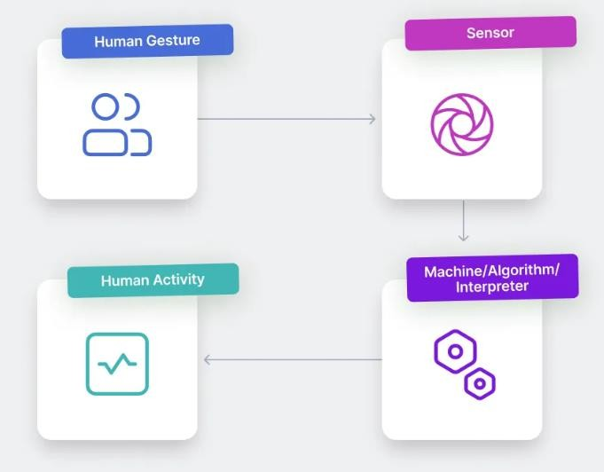

Figure 1-1 Basic Human Activity Recognition Outline

Technologies / Tools for HAR Recognition

There are numerous types of accessible, affordable, and mobile sensors that can detect and transmit data through wireless networks [3]. Fig 1-2 depicts some of the technologies utilized for HAR.

Surveillance Cameras
The most fundamental and conventional approach to recognize activities is by utilizing surveillance cameras installed within a facility to observe human actions. The Monitoring process can be carried out manually (by a person observing the footage and images captured from cameras) or automatically.

Depth Cameras
The other method to recognize the human activity is Depth camera. One limitation of traditional cameras is that they rely on light, which means they cannot work in complete darkness. It can gather data about the human body and generate a 3D virtual skeleton. One drawback of employing depth cameras for activity recognition is their high cost, which can be seen as a disadvantage.

Wi-Fi
Over the past decade, HAR research has undergone a paradigm change from method bound to specific devices to techniques that are not reliant on devices. Researchers have begun to employ wireless network elements such as Channel State Information for activity detection. There have been numerous presentations of Wi-Fi-based systems for location, monitoring, and detecting falls. Wi-Fi offers the benefit of being unobtrusive because users are not need to carry any gadgets.

Proximity Sensors

It is a form of electrical sensor that can detect the presence of objects in close proximity without requiring physical contact. In gesture recognition algorithms, proximity sensors are widely used.

Accelerometer

An electromechanical device that can detect and measure acceleration is called an accelerometer. Acceleration is detected in all directions. The accelerometer is commonly utilized in solutions for recognizing movements, postural recognition, identification of falls, monitoring, ambient supported living, everyday activities, and so on.

Magnetometer

Magnetometers are employed to gauge the magnetic field and, in some cases, the magnetic field's direction. Several applications for recognizing activities use this specific sensor.

Motion Sensors

The presence or movement of a subject in a specified region is detected by motion sensors. Sensors that detect movement are widely employed in HAR, namely in detecting movement, monitoring, and human counting.
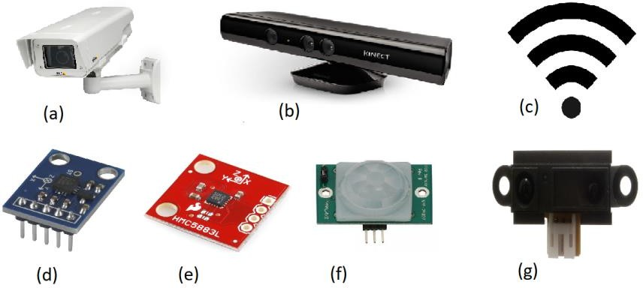

Figure 1-2 some technologies used for activity recognition: (a) Surveillance (b) Depth Camera (c) Wi-Fi (d) Accelerometer (e) Magnetometer (f) Motion sensor (g) Proximity sensor

Comparative Analysis of Sensors

HAR has been researched by several researchers from a variety of aspects, including as sensors and algorithms. To gather data on human activities during HAR, numerous sensors are employed. The visual based sensors, video or image based data recorded through various computing techniques. It involves video cameras, images cameras to monitor the physical activity. These type of sensors have several privacy issues for users. The body-worn sensors which are not easily comfortable for users because they work outdoor and less intrusive. Physical activity can be recognized by collecting data through wearable sensors, preprocessed and evaluated using classification algorithms. Millimeter-wave radar data-based HAR has become more common because to the development of radar sensors. In compared to other methods, radar data protects personal privacy better and is more user-friendly. Based on the type of sensor, HAR techniques are classified as wearable devices, cameras, and millimeter-wave radars[4]. HAR has become an active and comfortable study field with the widespread use of portable and wearable smart technologies. The development of affordable sensors in wearable technology, including smartphones and smartwatches, has made it possible to quickly transmit and analyze continuous streams of time-dependent data. Smartphones are frequently used by most people in the worldwide. It is reported that the National Development Commission survey of Taiwan in 2019, many Mobile users have been found almost reached 29.25 million which is indicating that 1.24 smartphones per person [5]. Therefore, smartphones are widely spread and involves in every user daily life. Table 1-1 displays the benefits and drawbacks of various sensors.

Table 1-1 Comparison of sensors

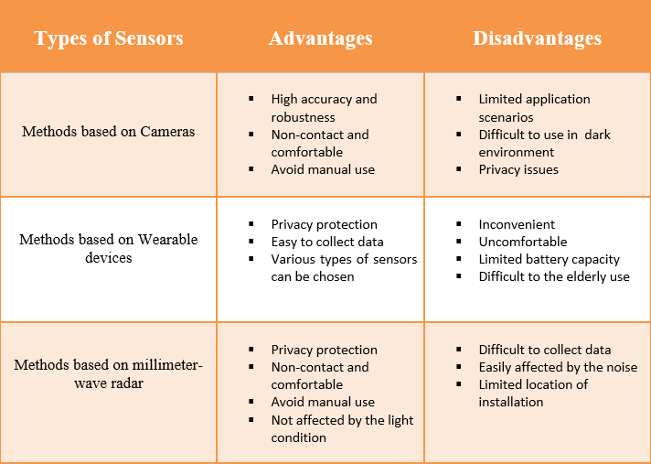

Applications of HAR

HAR has been widely used in many application areas such as detecting tracking exercise in sport science [6], surveillance activities [7], falls for elderly people healthcare monitoring, and action recognition in both indoor and outdoor, athletics [8], smart homes [9] and many other applications have been used to recognize and detect human behavior in well-mannered method. Some are discussed as below:

Healthcare

HAR has significant implications for healthcare and well-being. It permits remote monitoring and detection of anomalous activities or behavioral patterns in individuals, particularly the elderly or those suffering from chronic conditions. This can result in early intervention, prompt medical aid, and improved overall health outcomes.

Safety and Security

HAR is critical in improving safety and security. By detecting suspicious or unusual activities, it assists in video surveillance, population monitoring, and danger detection. Personal safety wearable devices, such as fall detection or emergency warning systems, can also incorporate HAR.

Human computer Interaction

HAR improves human-computer interaction by enabling for natural and intuitive interfaces. Gesture recognition, for example, enables users to interact with devices and systems through hand movements rather than traditional input devices. This affects interactive technologies such as gaming, virtual reality, augmented reality, and others.

Sports and Performance Analysis

HAR is used in sports analysis to track and analyses athletes' movements and performance. It provides coaches and trainers with important information on technique, efficiency, and injury avoidance. HAR enhances the viewing experience for fans by giving real-time statistics and visualizations.

Gesture and Motion control

HAR enables gesture and motion recognition, allowing users to interact with devices or interfaces without making physical contact. This technology has applications in gaming, virtual reality,

robotics, and other industries, improving user experiences and expanding the possibilities for human-machine interaction.

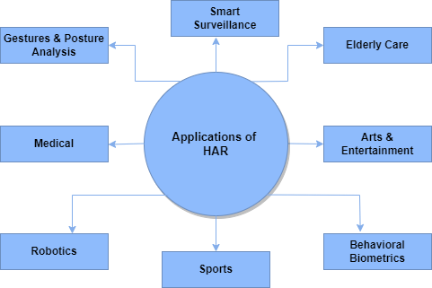

Figure 1-3 Applications of Human Activity Recognition

Limitations of HAR

Some of the HAR system’s Challenges [10] are listed below:

Complexity of modeling composite activities:
Although fundamental actions like walking, running, and sitting are reasonably easy to identify, complex activities like practicing exercises with various patterns are substantially more difficult to model and recognize. There are very few datasets that contain activity data on such parallel activities.

Lack of relevant information in activity datasets:
There are many available datasets in HAR that use multiple sensor modalities. The datasets are not uniform; for instance, the majority of datasets lacked crucial information about test subjects, such as their ages, heights, ranges, and weights.

Data Privacy or Lack thereof:
Another unresolved issue is the preservation of data privacy. The complex data privacy policies, together with system latencies, have a significant impact on the HAR system's performance. Audio/video signals require the use of complex signal processing techniques.

Imbalance dataset:
The data for commonly performed activities such as walking, talking, and running is abundant, data for unusual activities like unintentional falls from diverse positions is extremely rare, even in specialized databases. As a result, there often exists a class imbalance in data for distinct types of activities.

Statistics

The World Health Organization (WHO) defines physical activity (PA) as any movement, whether for leisure time, transit to and from places, or as part of a person's profession. On March 11, 2020, the WHO formally declared the global epidemic of Coronavirus disease 2019 (COVID-19) [11]. For more than a year and a half, the COVID-19 virus has rapidly spread across the world, leading many people to isolate themselves at home or in certain places. As a result, people's physical activity is limited. According to a recent study, physical inactivity harms more than 5 million people worldwide and places a heavy strain on global public health systems. [12].To keep healthy whether isolated at home or quarantined, people should keep up their physical activity levels. People's activity status can
be monitored and controlled using a HAR system.

Objective

HAR is to identify a person's actions based on a set of data collected by sensors. The purpose of the research is to improve the model's performance and accuracy in recognizing human actions by applying Deep Learning Techniques.

Thesis Structure

This thesis uses accelerometer data from smartphone sensors to demonstrate deep learning-based human activity detection. The remaining part of the thesis is structured as follows:
Chapter 2 covers review of the existing work in the field of Human Activity Recognition. It also contains important terms and definitions.
Chapter 3 presents the proposed HAR framework including the dataset, preprocessing techniques, and classification models for obtaining Smartphone sensor data.
Chapter 4 This chapter describes the outcomes of the proposed model. The evaluation metrics used to analyze the results are also covered. Finally, other state-of- the- art methods are also discussed.
Chapter 5 presents the conclusion of our research based on an evaluation of the results.

Chapter 2: Literature Review

The classification methods and techniques for Human Activity Recognition are reviewed in this chapter. This chapter begins with a study of HAR approaches, HAR datasets that are publically available, preprocessing methods, segmentation, feature extraction and evaluation metrics and in the last briefly explain different techniques of machine and deep learning

Notion of “Human Activity”

HAR is a subfield of artificial intelligence and computer science with an emphasize on developing systems for recognizing and understanding human behaviors using sensor inputs. Any movement, gesture, or physical action that involves the release of energy is referred to as human activity[13]. Human Activity, in other words, can also refers to an individual's actions and movements that can be detected, analyzed, and classified using sensor data and machine learning algorithms. The main purpose is to identify a person's activities by utilizing several innovations such as cameras, motion detectors, location gauges, and time. Throughout the day, humans perform a variety of daily activities. The daily activities of jogging sitting, walking, running and other similar motions are mentioned. Human activities are spilt into two distinct groups based on body motion and function. Human body motion and posture, such as walking, jogging, and sitting, are included in the first group, Simple Human Activity. The second category, complex human activity, Simple human activities are combined with a specific function to become complex human activities [14]. The complex activities are included such as cooking, reading, and watching TV. Some examples of action based activities as shown in Fig 2-1.

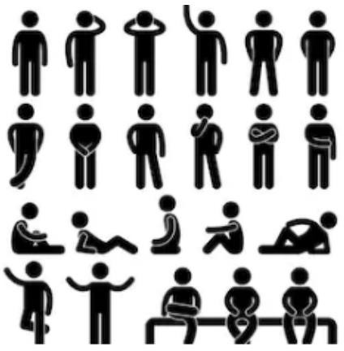

Figure 2-1 Examples of Action Based Activities

Human Activity Recognition Approaches

Collecting data via multiple sensors is the first step in activity recognition. For many years, some of the IMU (smartphone) sensors had been researched to improve HAR performance. Sensor Modalities are classified into several categories. These sensors may be wearable, vision-based systems, depth-based, or sensor-based technologies [15]. Vision-based approach, which makes use of a camera to record data about the actions taken by people. Different actions can be identified by using computer vision algorithms on the data that has been gathered The primary focus of HAR research has shifted to a paradigm focused on sensor-based techniques due to low cost and developments in sensor technology. Classification of HAR Approaches as shown in Fig 2-2.

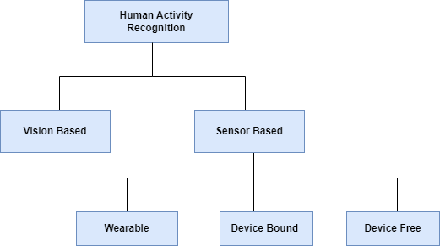

Figure 2-2 Classification of HAR Approaches

Vision Based

The visual based sensors, video or image based data recorded through various computing techniques. It involves video cameras, images cameras to monitor the physical activity. Computer Vision (CV) based HAR methods still have a few limitations such as the fact that they require adequate ambient conditions (such as brightness, light, and so on). Video-based systems have proven to be effective in identifying human movement, they do have some drawbacks. These include privacy problems, expensive expenses, and restricted coverage because they can only monitor a specific area. Users' privacy is at risk by these types of sensors.

Sensor Based

Sensor-based HAR systems, on the other hand, are more feasible because they capture activity data using wearable sensors, smartphone sensors, and so on [15]. Such types of sensors like accelerometer, gyroscope and magnetometers are frequently embedded in devices like smartphones, smart watches and armbands which engage with the human body and move with it.
      - Wearable sensors: One type of sensor modality that can detect and monitor human activity is wearable sensors. These sensors may be attached to the body or concealed within bands, smartwatches, clothes, and cellphones. Internet of Things (IoT)-based sensor devices such as gyroscopes, magnetometers, accelerometers, electromyography, electrocardiography, and others are all secure and can even be worn on the body to record motions. [16].
      - Device bound: In the device bound or object-tagged method, sensors are attached to daily items rather than being worn on the body.
      - Device-free: Sensors that do not require a device can be placed directly in the environment to record people' movement, communication, and action-based activities. The most prevalent type of these sensors are RFID (Radio Frequency Identification Technology) sensors. Wireless internet, Bluetooth radio, and RFID-based sensors are examples of radio frequency sensors[17].

Publically Available dataset for HAR

Different datasets for human activity recognition are as follows:

UCI-HAR Dataset

University of California, Irvine's (UCI) significant dataset which is publically available in [18]. HAR

dataset has been extensively used in several publications and comparisons. The experiment included an overall total of 30 participants. They engaged six everyday activities: walking, descending stairs, standing, sitting, ascending stairs and lying down. At a frequency of 50Hz, the built-in sensors recorded both linear acceleration and angular velocity in all three directions. The raw sensor data was processed using a number of different data pre-processing techniques, including time-series sampling and noise removal. Sliding a 2.56 second window was used for the time-series sample.

WISDM Dataset

The HAR Sense dataset is the next popular publically available dataset. For data collection, accelerometer and gyroscope sensors are employed to perform HAR, one which has been used in [19]. The motion sensing dataset includes six different human actions such as walking, sitting, standing, going upstairs and downstairs and jogging. Two distinct smartphones and mounting places on the subject's body are used in this dataset, namely the front pocket and the waist. The sensors on both cellphones were used to collect 16 features in total. An 8:2 split of the dataset is used to create training and testing sets. Two distinct smartphones and mounting places on the subject's body are used in this dataset, namely the front pocket and the waist. The sensors on both smartphones were used to collect 16 features in total. The collection has 1,412,865 samples in total.

Opportunity Dataset

The opportunity dataset consists of recordings of gestures and locomotion settings. Dataset is publically available in [20]. Tri-axial magnetic field sensor, gyroscope, and accelerometer sensors are used in inertial measurements units (IMUs) to collect data. IMUs are placed on both wrists and upper arm to record data from various sensors. Activities that involve gestures include pulling out drawers or doors, drinking coffee, and more. Standing, walking, and lying are examples of

locomotion. In both cases, the 'Null' class is present. The sampling frequency was 30 hertz (Hz). Sliding windows with a set duration of 4.26 seconds and a 50% overlap between each window were used to collect the 113 signals.

PAMAP 2 Dataset

The PAMAP 2 dataset which is publically available in [21] comprises of recordings of 9 persons doing locomotion activities. This dataset contains twelve distinct activity classifications that are carried out. The activities covered in these classes include standing, seated, and lying down as well as jogging, running, bicycle riding, Nordic walking, stair climbing, vacuuming, and rope jumping. Data collected from these IMU’s are accelerometer, gyroscope, magnetometer and temperature sensors. With the sampling frequency of 100 Hz it means 100 values per second are recorded. 128 measurements total from the signals were collected into a fixed-size frame with 50% overlap.

UniMib Shar Dataset

The UniMib Shar dataset, developed by the Department of Electronics, Information, and Bioengineering at Politecnico di Milano, is used to identify human activity. The 30 participants in the study who participated in 12 different activities while wearing tri-inertial measurement units (IMU’s) on their dominant ankle, chest, and dominant hand provided the data. Walking up and down stairs, sitting, standing, walking, lying, standing up from sitting, lying down from standing, sitting down from standing, walking all the way up and down again, and lying up from lying are a few of the exercises. Data from three-axis accelerometers and gyroscopes were acquired by each IMU, resulting in a six-dimensional time series for each sensor.

Table 2-1: Publicly available datasets with various modalities

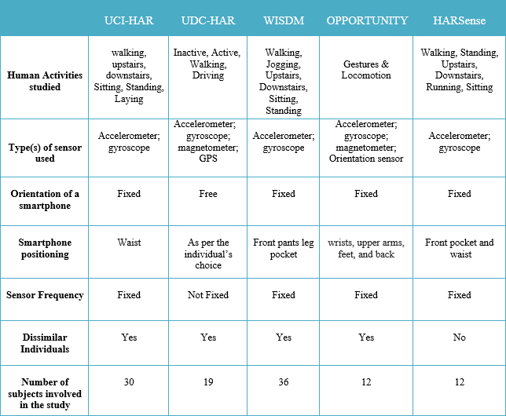

Data Acquisition

The first step in the Human Activity Recognition Process (HARP) involves data collection from sensors. Significant improvements in hardware and software technology have changed the habits of the whole population and industry during the previous decade. Microelectromechanical systems (MEMS) have increased capacity, precision, and accuracy while decreasing sensor size, cost, and power requirements. The IoT, on the other hand, has facilitated the spread of simple and quick connections between devices, objects, and the environment [22]. The popularity of smartphones in recent years has been mainly driven by their capacity to perform almost all online services that a user need, including communicating with others, playing games, reading emails, and more.
Wearable devices have recently become the focus of research. Smartphones have recently become the most popular wearable gadget when compared to ad hoc devices [23]. Smartphones, smart watches, home assistants, and drones are employed on a regular basis as a result of technological advancements and are crucial tools for various economic businesses such as item delivery, agriculture, remote healthcare and others. Nowadays, wearable sensors and smartphones are widely used among the population. The smartphone sensors play an important role for HAR. Sensors such as accelerometer, gyroscope and magnetometer which are in-built sensors of smartphones for HAR[24]. These sensors are frequently utilized in HAR tasks and classification.
- Accelerometer: The acceleration of an object over time, or its acceleration, is measured by the accelerometer, an electromechanical sensor. They are widely used in smartphones and records the signals in three-dimension axes. The unit of measurement is m/sec squared or g forces.

- Gyroscope: The gyroscope is used for changes in angle and measures tri-axial angular velocity.
The smartphone's roll, pitch, and rotation speed are calculated by identifying the movements of the device along the three axes of motion, respectively. The rate of rotation in radians per second is the raw data from the gyroscope sensor.
- Magnetometer: A magnetometer measures magnetic fields at a particular rotation and its measuring unit is Tesla (T).
Apart from accelerometers, gyroscopes, and magnetometers, HAR also employs a number of other, less common sensors. In the recent years, Barometric phone sensors are used by Azeem Javed Khan et al. [25] to categorize human vertical actions like going upstairs and downstairs. Sundholm et al. uses a textile based surface pressure for activity recognition. Human activities are associated with specific types of surface like sitting on a floor, walking, running, working out on a fitness mat etc. In this work it uses a pressure sensor to detect the human activities such as lying, sitting.
Imran et al. [26] proposed a CNN classification model in which electromyography (EMG) signals are used for hand motion detection. Chen et al. [27] proposed the evaluation of chest acceleration data was a proposed technique for human activity recognition utilizing wearable electrocardiography (ECG) signals. Daily actions including walking, standing, coughing, and lying down were all included in the activities taken into account in this methodology. ECG signals are used to identify human activities.
The accelerometer is the sensor that is most frequently used to detect human activity. Most of the time, a device with an accelerometer and gyroscope are used to learn more about the movements of the device and possibly determine its position. Stephen et al. [28] demonstrated a data collected in which ten participants individuals carried smart phones at different positions. The gyroscope-based

classification is used for better results than accelerometer. Furthermore studies combined accelerometer with gyroscope, accelerometer, gyroscope and magnetometer, accelerometer with GPS and may other combinations.
In data collection, sampling rate is crucial. It is defined as the data sampling rate, which illustrates the number of data points collected in a single second. A sample rate of 20 Hz, for instance, indicates that 20 values are recorded per second. And it is expressed in Hz. various sampling rates have been considered in the literature. Daniela et al. [29] the sampling rate is 50 Hz. The Samsung Galaxy Nexus 19250 and equipped with tri-axial accelerometer, in [30] at 32 Hz.

Data Preprocessing

Before being used for activity recognition, unprocessed sensor data from devices that are worn or other sources must first be cleaned, transformed, and prepared. This is known as data preparation in the context of HAR. Based on sensor data, HAR involves identifying and categorizing human behaviors like walking, running, or sitting. In other words, following data capture, the raw data obtained by motion sensors may contain noise and must be processed, modified into a readable format. Signals are elaborated after data collection to remove noise from the user and the sensors, and then the signals are used to create the data. Raw sensor data frequently contains artifacts caused on by the physical activity itself, by the instrument, or by electronic instability. Data must be cleaned in order to remove these artifacts from the signals.
Additionally, the linear acceleration caused on by both gravity and body motion is combined in the accelerometer output. Due to the impact of gravity on classifier accuracy, it is common to remove the gravity element from the raw signal. In Fig. 2-3, the primary preprocessing tasks are illustrated.

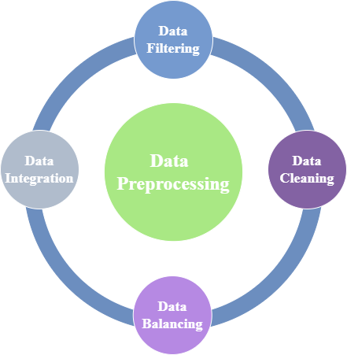

Figure 2-3 Steps of Data Preprocessing

Data Filtering

A filtering technique is typically used for the reasons stated above. To remove the noise in the raw data, filtering process is normally executed. High-pass, low-pass, and average smoothing techniques are frequently employed [31][32].
- High-frequency component of the accelerometer signal is primarily connected to the individuals' actions. A high pass elliptic filter with a cutoff frequency of 0.5 Hz is employed to eliminate high-frequency noise from the data.
- While the accelerometer signal's Low-frequency component is primarily connected to the presence of gravity. A low pass elliptic filter with a cutoff frequency of 20 Hz is employed to eliminate gravitational acceleration from the data.

Data Cleaning

The Data cleaning process are used to 'clean' data by replacing missing values, deleting inaccurate and incomplete data, smoothing noisy data and correcting inconsistent data from the dataset. Some data cleaning techniques are as follows:

Missing Values

You have many options when dealing with missing data [33]. Some of them are:

      - Filling up missing values manually

      - Using the standard value in place of the missing value

      - Use the attribute's mean, median, and mode as a replacement for a missing value.

      - Missing values can be predicted and replaced using methods such as regression and decision trees.

Noisy Data

Noisy data often refers to random inaccuracy or the presence of unnecessary data points [34]. Here are several strategies for dealing with noisy data.
- Binning: This technique is used to clean up or handle noisy data. The sorted values are divided into groups and saved after the data has been sorted.
- Regression: When there is unnecessary data, this is used to handle it and smooth it. Purpose of regression helps in determining which variable is appropriate for our analysis.
- Clustering: This is used to locate outliers as well as group the data. Unsupervised learning commonly employs clustering.

Data Balancing

The initial data set is incredibly imbalanced. Machine learning systems are significantly negatively impacted by imbalanced data [35]. These techniques fail to appropriately capture the distributive properties of the data in datasets with uneven class distribution. As a result, misclassification of minority classes would be higher than misclassification of majority classes, resulting in a decrease in the overall accuracy of learning algorithms. Furthermore, few papers in HAR included extensively with this issue such as in this dataset [36] sitting represents 44.2% of the data whereas jogging represents for 0.3%. In general, several alternative approaches, like as over-sampling and active learning, were introduced in [35] to deal with imbalanced data.

Data Integration

Data integration [34] has shown to be a crucial component of the process because data is now being obtained from multiple sources. This could lead to repetitive and incorrect data, which would have a negative influence on the accuracy and speed of a data model.

Data Segmentation

Data segmentation is a further essential phase in HAR. The data is continually pre-processed before it can be segmented, which separates the continuously streaming (preprocessed) data into discrete segments for feature extraction and model training. Windowing is often utilized in HAR in three ways: activity-based windows, event-based windows, and sliding windows.

Activity-based Windowing

As illustrated in Fig.2-4, finding patterns in activity changes is employed to identify the start and end points of each window in activity-defined windowing. Each window likely represents a specific activity.

Event- based Windowing

Streaming data events are separated into fixed time frames in this case. Due to its simplicity of usage and suitability for dealing with continuous data sensors, it is the segmentation method for activity recognition that is most frequently employed [37]. The selection of the window length is the cause for many of the classification problems that occur while using this method. If a short duration is chosen, the window may not include enough information to make a decision. However, if the time limit is exceeded, information from numerous activities can be saved in a single window.

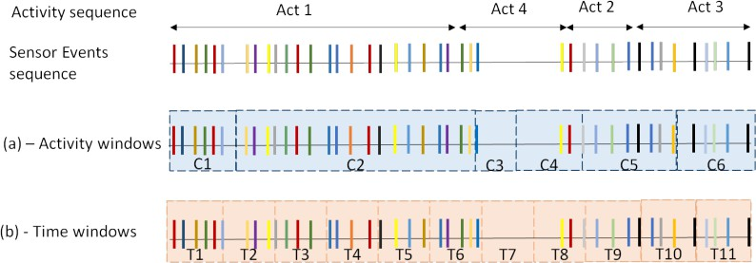

Figure 2-4 (a) Activity windows (b) Time windows

Sliding windowing

As illustrated in Fig. 2-5, the data is separated into fixed-size windows with no intervals or pauses between them. In some cases, these windows may overlap. The fixed-size no-data-overlapping window segmentation method is used by the majority of activity recognition systems [38].

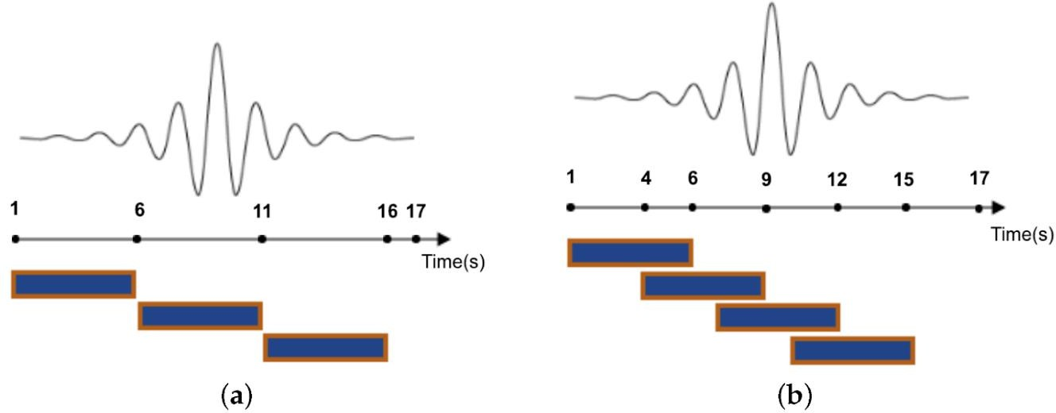

Figure 2-5 5s (a) Non-overlapping (b) Overlapping

Feature Extraction

Feature extraction refers to the process of converting raw data into usable numerical attributes while maintaining the original data[39] . The pre-processed signal segments are further processed to extract significant features. According to the research, utilizing a collection of features rather than raw data enhances classification accuracy [40]. As illustrated in Fig. 2-6, Hand-crafted features and learned features are the two most common types of features.

Hand-Crafted Features

Handcrafted features are the most common type of HAR feature. The phrase "hand-crafted" describes how a professional chooses features utilizing heuristics. A domain expert creates features that convert sensor data into a high-level representation. The handcrafted features are divided into two categories: time domain and frequency domain. A signal's time domain is changed to its frequency domain through the Fourier transformation.

Learned Features

Learned Features are unsupervised learning features that are automatically discovered. Without requiring human input, automated feature extraction extracts features from signals using specialized algorithms or deep networks. This method may be useful when it is necessary to move quickly from collecting unprocessed data to developing machine learning algorithms. The feature extraction technique is useful if you have a large data collection and need to reduce the quantity of resources without losing any critical or relevant data. Feature extraction facilitates the removal of redundant data from a data source. Finally, reducing the amount of data allows for easier model construction with less machine work.
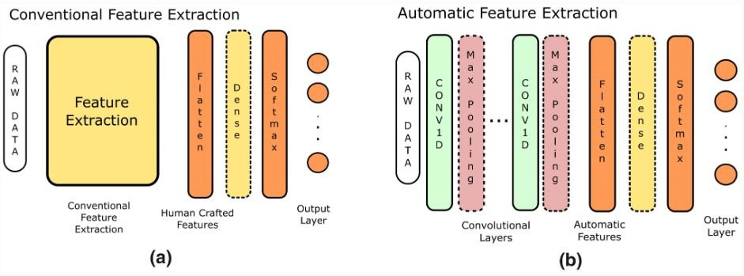
Figure 2-6 Conventional & Automatic Feature Extraction

Evaluation Metrics for HAR system

When evaluating the performance of HAR systems, several metrics are typically utilized. The evaluation parameters are used to determine by the HAR task's specific goals and requirements. Here are some examples of HAR system evaluation metrics:
- Accuracy: The most frequently used measure in HAR is accuracy, which is determined by dividing the total number of activities by the number of activities that were successfully classified. The accuracy of classification models indicates their overall performance.
- Precision and Recall: Precision and recall are measurements used in binary classification scenarios, which classify each activity as positive or negative. Precision is the proportion of correctly recognized positive occurrences among all expected positive occurrences, whereas recall is the proportion of correctly classified positive occurrences among all actual positive occurrences.
- F1 Score: When there is a class imbalance, the F1 score is a combination of precision and recall. It's the harmonic mean of precision and recall, resulting in a single statistic that balances the two.
- Confusion Matrix: For a more thorough evaluation of performance, a confusion matrix shows the number of true negative, false positive, true positive and false negative predictions for each activity. It assists in identifying specific areas where the system may be failing.

Table 2-2 Summarization of Evaluation metrics

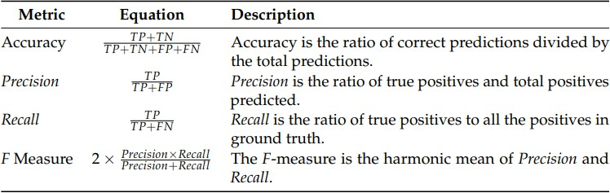

Traditional Classification Algorithm and Techniques

In supervised learning procedures, such as classification, you train a machine to do something based on data that has previously been classified by people. The training data consists of up of a fixed set of labels or categories that the system is able to learn. The system can categories incoming data into pre-determined groups by detecting patterns in the training data. [41].

Machine Learning Based Techniques

A machine learning (ML) algorithms can find patterns in a dataset automatically. Several supervised learning methods exist including K-NN, SVM, DT and Naïve Bayes. Some of the architectures examined in this study are described below.

Support Vector Machine

Support vector Machine (SVM) is a method for classification and regression in supervised ML. It is very helpful when dealing with difficult problems with a clear margin between different classes.

SVM [42] determines the optimal way to classify data depending on the position of the data with respect to boundary between positive and negative classes. This boundary, also known as a hyperplane, maximizes the separation of data points into different classes. Overall, due to its capacity to handle complex classification issues and find optimal separation between classes. SVM is an effective classification approach that is widely used in a wide range of fields such as picture recognition, text categorization, and bioinformatics. SVM has various advantages, including the ability to handle high-dimensional data, the ability to handle small to moderate-sized datasets well, and the ability to handle nonlinear relationships using kernel functions. Whereas SVM, can be computationally intensive and may struggle with large datasets. SVM is displayed in Fig. 2-7.

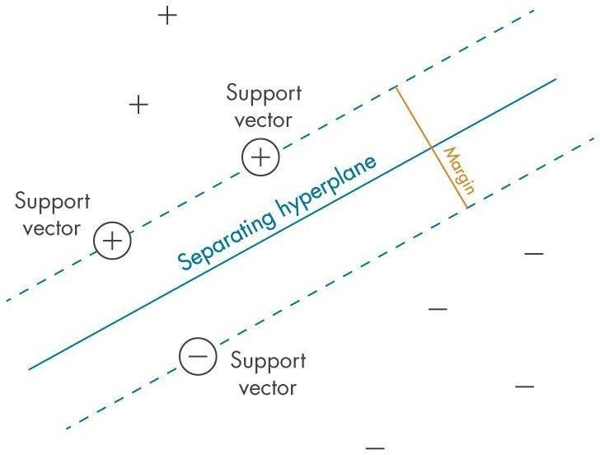

Figure 2-7 Support Vector Machine

Random Forest

Another popular ML method for classification and regression applications is Random Forest (RF). It is a method of ensemble learning that combines the predictions of numerous independent decision trees to provide more accurate and robust predictions. A group of decision trees or a random forest
[42] that is depicted in Fig. 2-8. The term "forest" in Random Forest refers to the grouping of decision trees. Each decision tree is created by manually using a randomly chosen subset of the training data and a randomly chosen subset of the features. This randomness is a major feature of RF helps in the introduction of variation among the trees. The bagging approach, allowing each tree to be trained on a random sample of the original dataset, is also used by RF in order to retrieve the majority vote from the trees. It has more generalization than a decision tree but is less interpretable due to the additional layers in the model. Random Forest offers several advantages:

- When compared to individual decision trees, Random Forest provides higher prediction accuracy and is less prone to overfitting.
- It is capable of handling a high number of input variables as well as numerical and category features.
- Random Forest can efficiently capture non-linear linkages and variable interactions.
- It provides feature importance estimates, demonstrating which features have the biggest influence on the predictions.

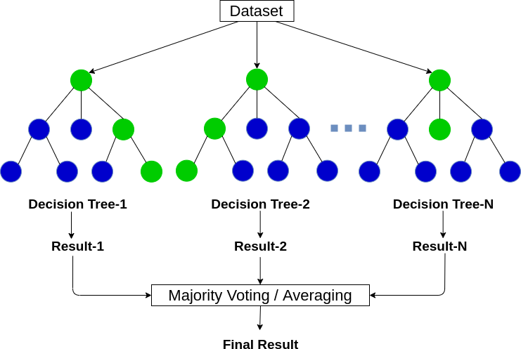

Figure 2-8 Random Forest

K-Nearest Neighbor

K-Nearest Neighbor (K-NN) is a basic but powerful ML method that may be applied to problems with regression and classification. It is an instance-based learning technique in which predictions are formed based on the similarity of input data to its K-NN. The K-NN [43] classification algorithm divides data into groups depending on how far apart the data points are from one another. According to this method, data points that are close to one another must be similar. As a result, the cluster closest to the classification data point will be used to group it. It is a slow learning strategy, as illustrated in Fig. 2-9.K-NN has various advantages:

- Simplicity: K-NN is simple to understand and apply, making it a good option for quick prototyping of baseline models.
- Flexibility: K-NN is capable of handling both numerical and categorical features, making it suitable for a wide variety of datasets.
- Non- Linearity: K-NN can identify non-linear correlations between variables because it is based on the distances between data points.

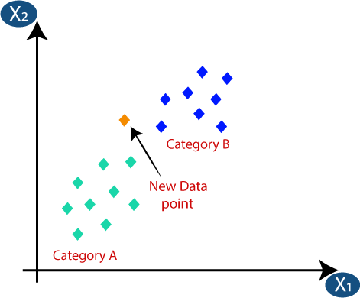

Figure 2-9 K-Nearest Neighbor

Naive Bayes

Naive Bayes is a machine learning method that is based on probability and statistics principles, namely Bayes' theorem. It is frequently employed for classification tasks in which goal is to assign a class or label to a given data point based on its features. The term "naive" refers to the feature independence assumption, which states that the features are completely distinct of each other given the class. This assumption reduces algorithm's computational complexity and makes it more
tractable.

Naive Bayes is well-known for its simplicity and computational efficiency. It can handle huge datasets with many features and performs well in text classification tasks like spam detection and sentiment analysis. Despite its simplistic assumptions, Naive Bayes frequently works well in practice, particularly when the independence assumption is reasonably well supported or when there is a considerable amount of training data available.

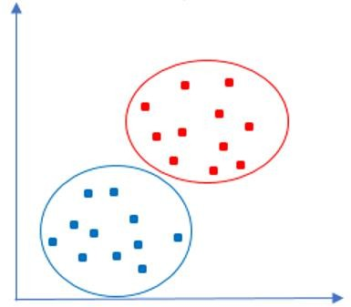

Figure 2-10 Naive Bayes

Machine Learning for HAR

Machine learning approaches have primarily been applied to activity recognition problems. Several studies for HAR using machine learning have been conducted in recent years. R. Jansi and R. Amutha
[44] proposed a novel sparse representation-based action recognition system in which eight different human activities including stand, lie –down, walking, jogging, sit, upstairs and downstairs are classified. The classification was done by supervised learning methods include SVM, DT and K-NN using smartphone sensors data. Smartphone sensors can detect human activity since they are ubiquitous and make important data available with ease.

Nadeem Ahmed et al. [45] collected a data from smartphones sensors in tri-axis accelerometer and tri-axis gyroscope. They performed twelve different human activities and the sensor data rate at 50 Hz. An SVM-based wrapper method and a filter method based on SFFS are combined to create a hybrid feature selection model. A smart sensor-based IoT-based human activity monitoring approach is described in Pooja Mittal and Navita's study [46] to continuously monitor the activities of elderly persons. The data was acquired from 30 subjects between the ages of 19 and 48 while they were performing daily life activities with waist-mounted smartphones embedded with Interial sensors such as Gyroscope, Accelerometer. They used different classification techniques named SVM, K-NN, DT, and RF and achieved 98.03% accuracy. A multi-sensor UCI dataset was given by Vidya and Sasikumar [47] using wireless sensor network nodes and an inertial sensor integrated inside a smartphone. Statistical feature extraction is accomplished using the Discrete Wavelet Transform and Empirical Mode Decomposition approaches. Various human activities are classified using ML classifier models. The eight different human activities are carried out on the WISDM dataset. Data from a smartphone's accelerometer is included in this dataset. On the dataset, four different ML algorithms were used: linear regression, logistic regression, SVM, and neural network. The Weka tool is used for classifier training. The performance and potential of ML algorithms were investigated by Abbas et al. [48].

Deep Learning-Based Techniques

Machine learning methods use handcrafted feature extraction methods. The smartphone and portable sensor-based HAR process's most challenging step was the extraction of relevant features. Because the majority of its handcrafted features were used in the existing HAR system, which is based on ML
techniques, it was unable to handle complex activities.

The performance of manually extract handcrafted features was found to be insufficient [49]. DL algorithms are more common than traditional ML algorithms due to their automatic feature learning capabilities. Deep learning reduces the amount of data preprocessing required for machine learning. To overcome the problem of manual handcrafted features, CNNs are common supervised DL approaches utilized in the HAR domain. Some of the other architectures of deep learning systems are: CNNs, LSTM, ANN etc.

ANN

With several hidden layers between the input and output layers, an Artificial Neural Network (ANN) is a type of neural network design used in DL. Because of their depth, these networks are commonly referred to as Deep Neural Networks (DNNs). A neural network is organized similarly to the brain of human being and is made up of artificial neurons, also known as nodes that are connected [50]. An input vector is converted into an output vector by layers of neurons in a neural network. Each neuron receives input and executes a function on it, which is often a non-linear function, before transferring the result to the next level.
These nodes are placed on top of one another in three layers:

- Input Layer

- Hidden layer
- Output layer
A subfield of machine learning called "deep learning" focuses on creating DNN and training them to understand input using structured representations. Deep learning is intended to allow a network to learn and determine features from raw data automatically, decreasing the need for manual feature engineering. The ANN network is seen in Figure 2-11.

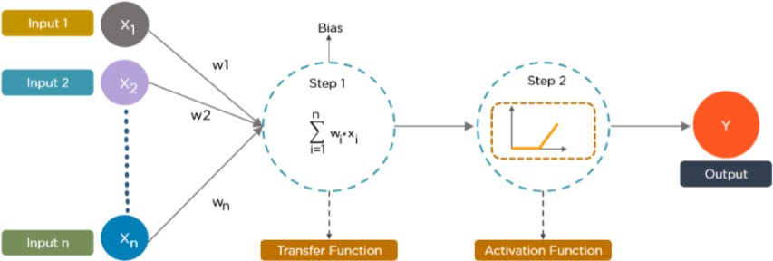

Figure 2-11 Artificial Neural Network

DNN have achieved remarkable success in a wide range of fields, including detection of speech, computer vision, and processing natural languages, and many more. Their ability to learn complicated representations from raw data automatically, combined with the availability of large datasets and processing resources, has contributed to their effectiveness in solving difficult machine.

Convolutional Neural Network

CNNs [50], sometimes known as ConvNets, is a DL algorithm used mostly for object detection and image processing. Multiple layers of CNNs process and extract data features. In 1988, Yann LeCun invented the first CNN, known as LeNet. Characters such as ZIP codes and digits were recognised. CNN has a significant advantage over its predecessors in that it uses automated feature extraction to achieve superhuman accuracy. CNN stands for Convolutional Neural Network, a type of neural network that is widely used in deep learning for vision related tasks such as picture classification,

recognition of items, and image segmentation process. The basic construction is depicted in Fig 2-

12. CNN operates through the following five major steps:

- Convolution Operation

- Activation Layer
- Pooling

- Fully connected laer

- Dropout Layer

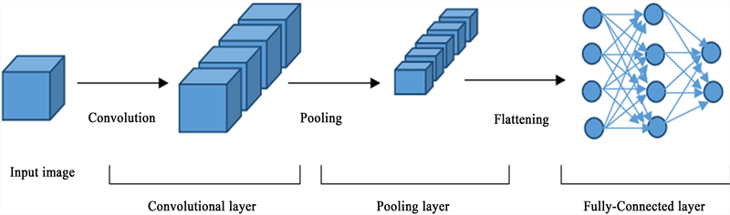

Figure 2-12 Structure of CNN

Convolution Operation:

In HAR, the convolutional layer processes input sensor data, which is frequently represented as a time series. To capture local patterns and characteristics, the convolutional layer applies filters to the input sequences. Convolutions are performed throughout the time dimension by each filter, extracting relevant information from distinct segments of sensor input. These learnt features can indicate temporal dynamics or unique patterns associated with various activities.

Activation Layer:
Following the convolutional layer, a non-linear activation function is applied to each convolutional filter's output by the activation layer. Common activation functions used in CNNs, such as ReLU (Rectified Linear Unit) introduce nonlinearity and allow the network to simulate complicated relationships between data and activities.

Pooling
To minimize dimensionality, pooling is frequently applied after a convolution phase. This enables us to lower the number of parameters, shorten training time, and avoid overfitting. Each feature map is downscaled separately by pooling layers, resulting in a reduction in height and breadth while retaining depth.

Fully Connected Layer
Layers are the building blocks of feed-forward NN that are fully connected (FC).The network's last layers are the FC layers. The output of the last convolution or pooling phase, which is flattened before being transmitted into the layer with full connectivity, serves as the input to this layer. The classification process gets started at this point.

Dropout Layer

In each training cycle, the Dropout layer, a regularization approach, randomly sets a fraction of input units (neurons) to zero. This avoids overfitting by reducing the reliance of neurons on particular characteristics and promoting the network to develop more generalized representations. Dropout causes the network to become redundant and noisy, requiring the development of robust features.

LSTMs

Deep learning frequently uses the Long Short-Term Memory (LSTM’s) structure, a type of RNN architecture, for dealing with sequential input. It was created primarily to address the vanishing

gradient issue that might arise in standard RNNs when dealing with extended sequences. LSTM networks are similar to RNNs in structure, but they include memory cells and gating mechanisms to capture and store information across longer sequences.
The main idea underlying LSTM is to allow the network to remember or forget information at different time steps. Four interconnected layers make up the chain-like structure of LSTMs, which communicate in a unique method. Figure 2-13 shows the network of LSTMs.
- To begin with, they forget irrelevant information of the prior circumstances.

- After that, the cell-state values are then selectively updated.
- Finally, the output of specific cell state component.
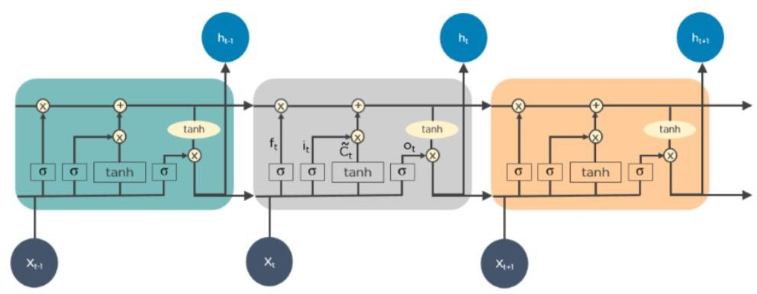

Figure 2-13 Long Short Term Memory

LSTM networks are particularly effective at capturing long-term relationships in sequential data and have found widespread success in applications such as audio recognition, natural language processing, sentiment analysis, and time-series prediction. They allow the network to retain important data across long chains and generate accurate predictions or classifications based on that data. LSTM is a key deep learning building block that has paved the way for more complex architectures and techniques in sequential data analysis.

Deep Learning for HAR

A significant amount of research has been published on the topic of HAR using computer vision and deep learning methods. DL algorithms can automatically extract relevant features. This leads to an extremely high performance of DL algorithms in smartphone-based HAR models. The HAR classification process has been completely dominated by CNN approaches. Peek et al.[51] Suggested another CNN model. An accelerometer and a gyroscope positioned on the waist were used to gather the data. The impact of several hyper parameters, such as the number of filters and filter size, on CNN performance is automated by CNN layers, which also automate feature learning. Yen et al. [52] proposed a CNN model for recognizing human activity based on wearable sensors like smartphones, which have built-in sensors like a microcontroller, gyroscope and accelerometer. The network structure of the one-dimensional CNN used in this study included a softmax layer, three layers that were fully connected, three dropout layers, and four layers of convolution. It produces probabilities for one of the six behaviors. The data sampling rate was set at 50 Hz with fixed-width sliding window of 2.56s. Mekruksavanich and Jitpattanakul [54] proposed a HAR framework for smartphone data. HAR model to identify six distinct actions such as going upstairs and downstairs, walking, sitting, standing, lying using 4-layer CNN-LSTM. In other work, Ghate and Hemalatha [55] described a hybrid DL approaches, combination of DNN with other LSTM, GRU using the WISDM and UCI-HAR public dataset. CNN-layers are used to classify manufactured features effectively. In this work Yang et al.[56], the DAPHNet-FoG dataset and the WISDM dataset were both utilized. The HAR framework uses convolutional layers and shallow characteristics acquired from smartphone sensors and wearable sensors. MacDonald et al. [57] presented a CNN-based HAR that recognizes 16 different lower limb motions by utilizing five different sensors, including a gyroscope and an accelerometer.

Abdul et al. [58] described a bidirectional LSTM and a CNN using two separate datasets. Data from smartphone sensors were used to create the UCI and WISDM databases. A body worn and smart phone sensor based HAR framework was proposed by Chattopadhyay et al. [61] . To demonstrate that the suggested model is effective, authors used four different datasets in their experiments; UCI, WISDM, OPPORTNITY and PAMAP 2. The proposed architecture is ‘‘ConvAE-LSTM’’. Tan et al. [62] proposed HAR framework, containing three different DL approaches namely; an ELA model consisting DNN, stacking CNN + GRU and GRU with different public datasets. An accelerometer and a gyroscope are examples of inertial sensors that were used to collect the data. In [64], a 1D-CNN with Bidirectional LSTM-based HAR system has been proposed by the authors. In this study, researchers performed their trials using data from Motion sense, UCI-HAR, and a single accelerometer smart phone sensor. Using WISDOM and Activity datasets gathered by wearable sensors, the authors of [65] proposed LSTM, CNN, and ConvLSTM models based HAR solutions. Recently, [66] suggested a regularized AE- based HAR architecture based on body-worn sensors.
Abu Yousuf et al. [75] suggested a HAR architecture that combines LSTM and CNN. In this study, inertial sensors from smartphone sensors, including linear acceleration, magnetometers, accelerometers, and gyroscopes are frequently employed. The authors employed the MHEALTH, H-Activity, and UCI-HAR datasets to prove feasibility of their research. Table 2-3 compares these methods in comparison.

Table 2-3 Review of other Machine & Deep learning models

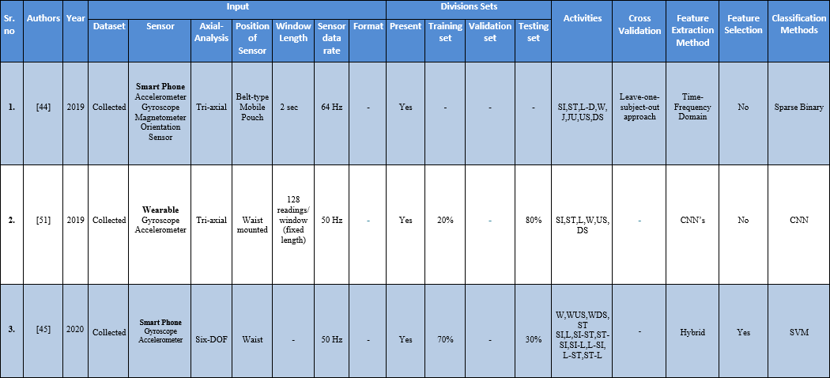

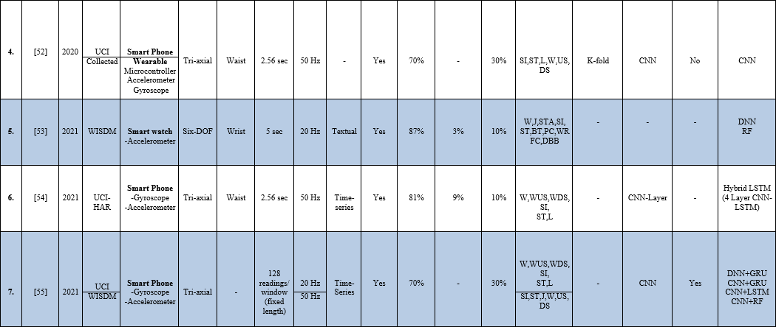

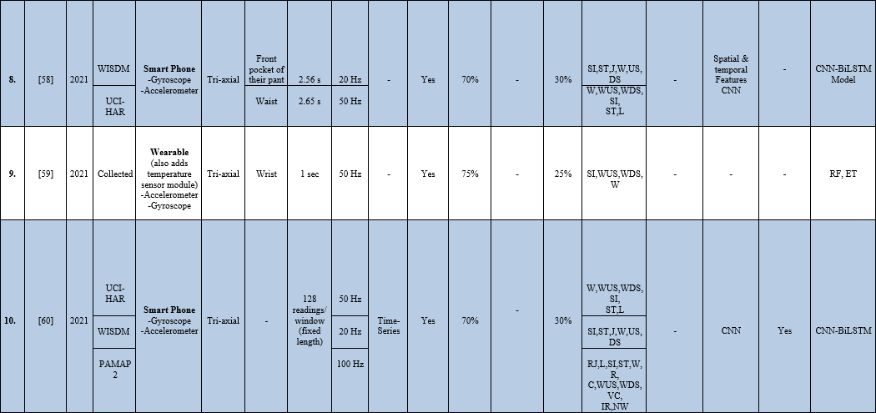

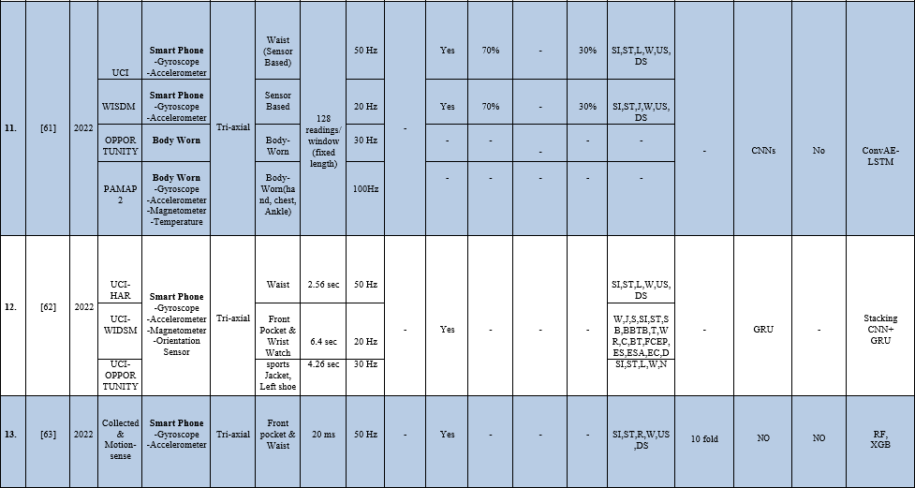

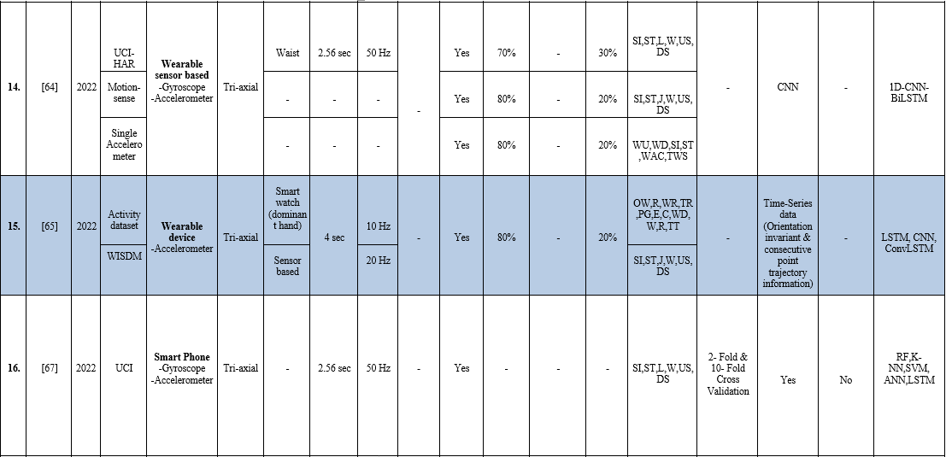

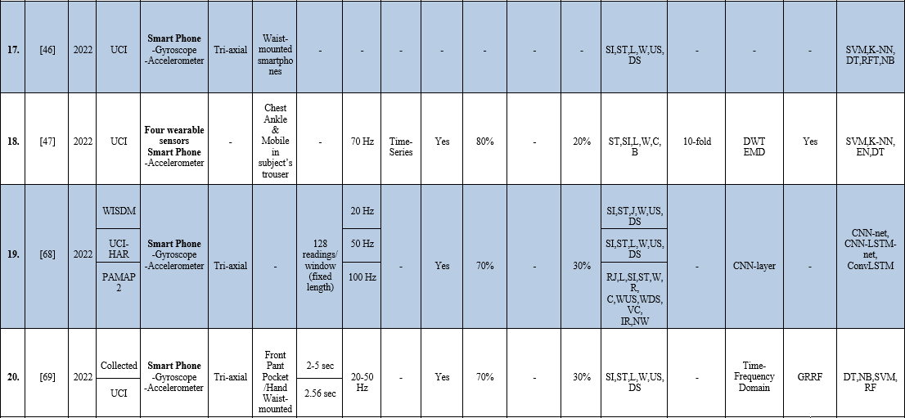

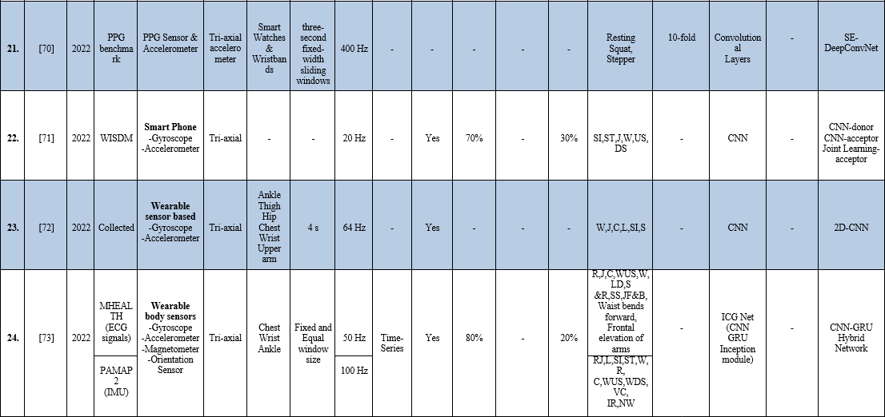

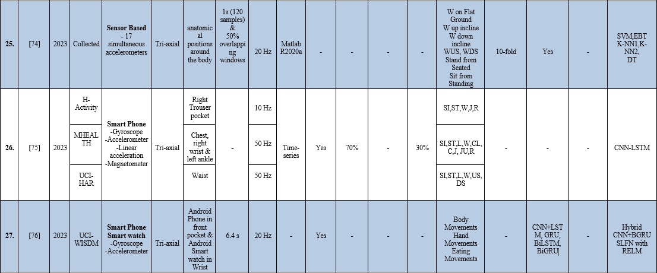

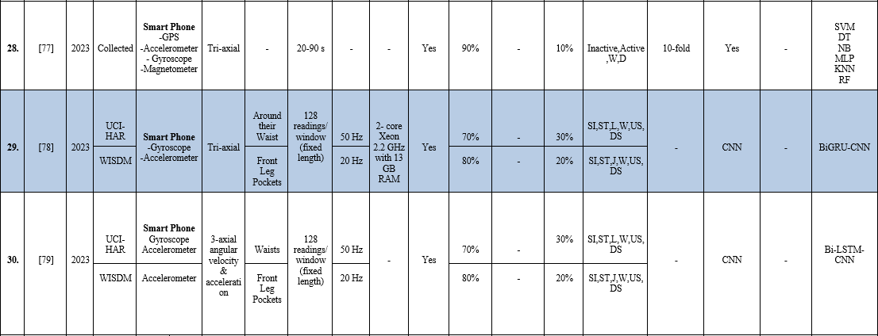

Chapter 3: Materials and Methods

The dataset used to classify Human Activities is described in this chapter. It explains an overview of the methodology utilized in general, followed by the sequence of steps used to perform HAR, as well as the CNN method used for classifying Human Activities.

Description of Dataset

The dataset for this study's Wireless Sensor Data Mining (WISDM). This Experiment included the participation of 36 individuals. The dataset contains a total of 1,098,209 samples. Each subject performed six different everyday activities. For the purposes of this experiment, each individual was required to have a smartphone running the Android operating system. The subjects were instructed to keep their smart phones in the front pocket of their trousers. Furthermore, the dataset by recording distinct human actions such as sitting, walking, jogging, standing, downstairs, and upstairs for specific duration of time. The dataset is consist of tri-axial accelerometer and gyroscope sensors, and the frequency of data collection is set. A rate of 20 samples per second was used to obtain accelerometer data, every 50 milliseconds. Data is separated into two basic categories: train set and test set. The remaining 20% was set reserved for testing, with the remaining 80% being used for training. Table 3-1 provides details about our dataset.
Table 3-1 Dataset

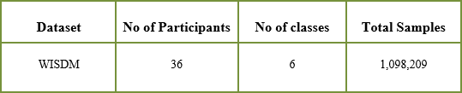

Fig 3-1 shows the percentage of total samples connected with each activity, indicating unbalanced nature of WISDM dataset. Walking (38.6%) and standing (4.4%) have the highest and lowest prevalence rates, respectively.

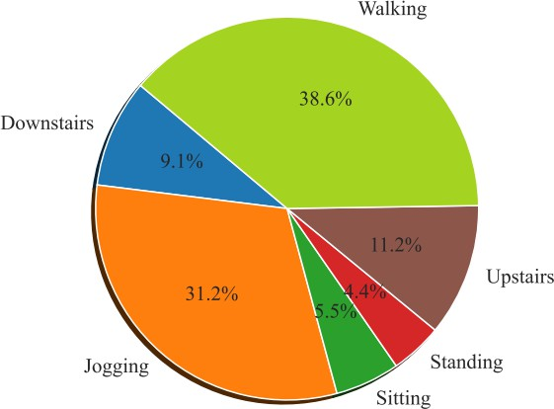

Figure 3-1 Example of WISDM dataset

Human Activity Labels

Labelling a dataset refers to the process of assigning activity labels or categories to recorded sensor data that captures human movements or actions. Data labeling is a part in the development of a model that occurs during the preprocessing stage. Once the dataset has been appropriately labelled, it may be used to train model that can learn from the labelled sensor data and predict human actions. The focus of this work is on recognizing a few fundamental human behaviors walking, sitting, standing, running, and moving downstairs and upstairs are all examples. As indicated in Table 3-2, each activity class is assigned a value ranging from 0 to 5 and will be discriminated using the CNN model.

Table 3-2 Human Activities and their Labels

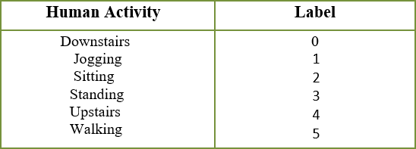

Accelerometer Reading

This research study takes several actions into consideration, including jogging, going upstairs and downstairs, walking, standing and sitting. These specific activities were chosen for two primary reasons. First of all, a lot of people participate in these activities every day and they are very common. Second, because these activities include motions of the body that occur over a long period of time, recognizing them becomes a simple process. Furthermore, the majority of such behaviors show recurring patterns in bodily movements, which may help in the identification of these behaviors. The accelerometer records readings (acceleration values) along three axes, while recording data for each activity. In this study, the x-axis records horizontal movement of the subject's leg. The body's vertical movement, including both up and down motion, is captured by y-axis. Finally, z-axis captures forward movement of the subject's leg. Figures represent an estimated periodic pattern for the activities as well as a link between time and accelerometer sensor results. Each figure has three subplots that represent the tri-axes' acceleration values. As previously indicated, data is collected at a frequency rate of 20 Hz, which translates to 20 samples per second.

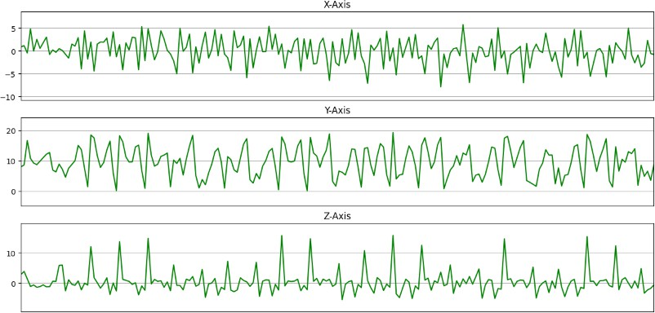

- Walking

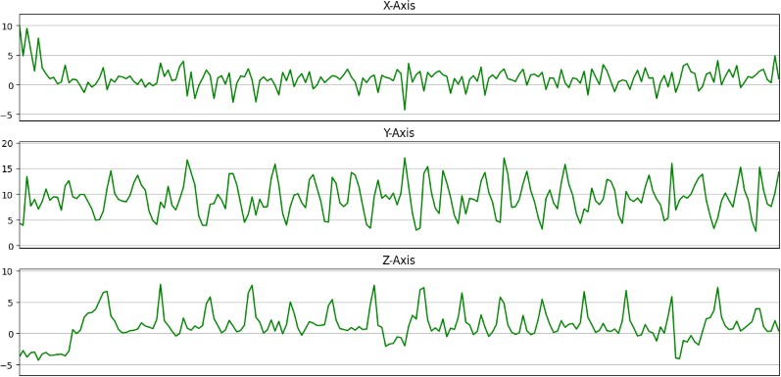

- Upstairs

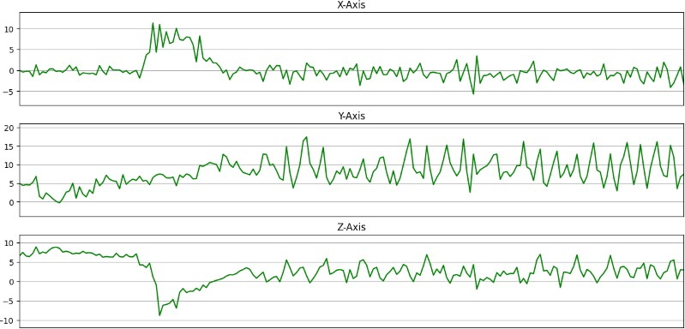

- Downstairs

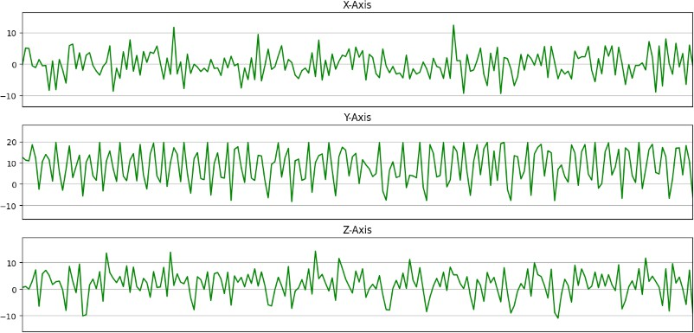

- Jogging

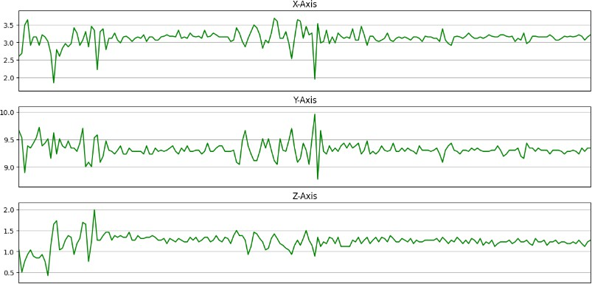

- Sitting

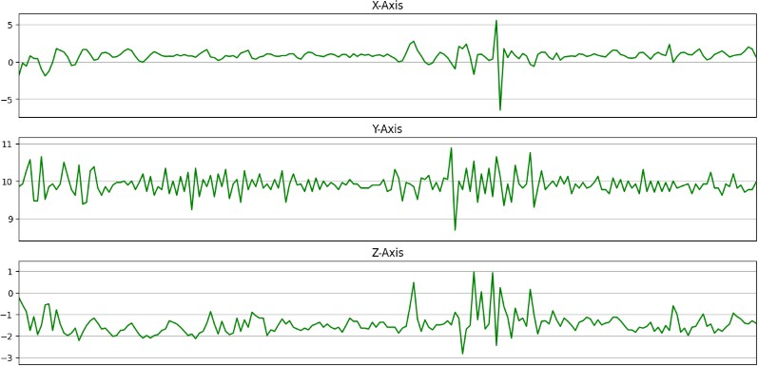

- Standing

Pre-processing of data

In HAR, data preprocessing is the term for a collection of methods applied to raw sensor data before it is used by activity recognition algorithms. The pre-processing techniques we are using in this research work are listed below:

Data Balancing

A balanced dataset is one that has an approximately equal or proportional amount of samples or instances for each activity class. In simple terms, each activity class is represented similarly in the dataset. In human activity recognition, balancing the dataset includes techniques such as oversampling, under sampling, or class weighting that adjust the class distribution. A balanced dataset is necessary to ensure that the model is trained and evaluated on an equal number of examples for each activity type. The WISDM dataset are highly unbalanced. Figure 3-3 shows that there is more information available for jogging and walking than for other activities. Because a large number of training samples have been collected during the actual experiment. For model development and human activity recognition, training samples are essential. Because CNNs are supervised DL models, a larger number of samples helps the CNN model train better, and the model results in improved prediction, assuming that the number of samples for each of the six categories of activities is equal.

Data Uniformity

The experiment included a total of 36 participants, as indicated in Fig 3-2. Additionally, it is evident that user 20 recorded most the data for the experiment, whereas user 4 clearly captured the least amount of data.

As a result, participant data collecting differs from one another. Balanced data for each of the six activities, on the other hand, is required for better prediction and identification of human behaviors.

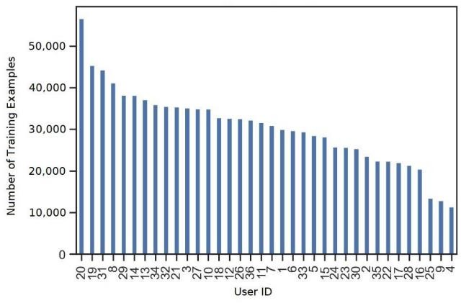

Figure 3-2 User’s Training Examples

Overfitting Avoidance during training data

The data is highly skewed towards jogging and walking as shown in Fig 3-3. If this problem is not solved, it may lead to overfitting during training, resulting in an unwanted reduction in the performance of our ML model [80]. Since each of the six activities should be given equal Importance.

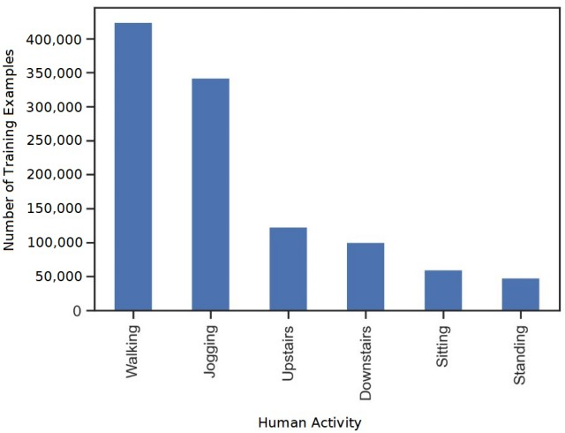

Figure 3-3 Examples of Training by Activity type

In such a way, all six activities should be given equal importance, the smallest possible number of examples must be used to observe the action. There are 3555 examples of standing action. To balance the data, 3555 training instances from each of the six actions are employed. Figure 3-4 depicts an equal number of training experiences for each activity group.
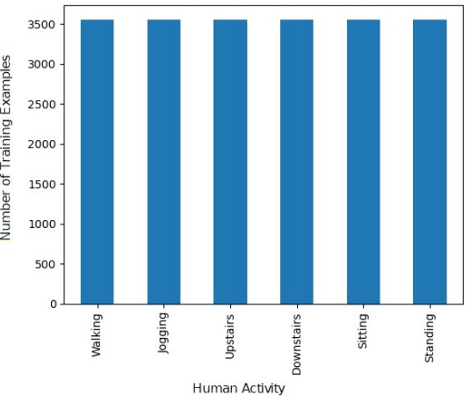

Figure 3-4 Balanced number of examples

Data Standardization

Standardization data in the context of HAR refers to the process of normalizing or scaling input data to a consistent range or distribution. Sensor data, such as accelerometer and gyroscope readings, are used in HAR to classify and identify human actions. Standardization is an important preprocessing step in HAR since it ensures that the input data is consistent and comparable across different sensors or individuals. You can remove variances in the scale, mean, and standard deviation by standardizing the data. The user's action's coordinates in the three directions. The respective values show a greater magnitude of variation between them. A standard scaling technique was used to reduce the variance in the data, producing values with significantly lower variance, as shown in Table 3-3.

Table 3-3 Standardize data
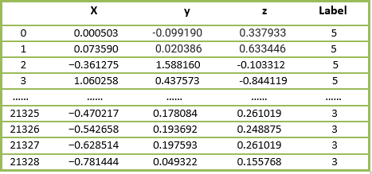

By removing the standard deviation and scaling to unit variance, the characteristics are standardized. Consider the following example X. The sample X's standard score is determined as follows:

Z=(X-u)/s

To standardize the data, the mean (u) and standard deviation (s) of the training samples were calculated. To obtain the standardized data, the data was fitted and transformed using the fit_transform () method during implementation.

Frame Preparation

Frame Preparation in HAR refers to the process of transforming the sensor data into frames or segments that can be used for activity recognition. Though only a limited amount of data can be sent into the neural network at once, data frame preparation is required because the individuals will be performing their activity for an arbitrary amount of time. As a result, using a data frame, it is possible to analyze data in two dimensions. For additional processing, the coordinates of the x, y, and z columns' data type is changed to "float64". The frame size is set to 80 pixels and frequency is set at 20. This means that the model will be fed 80*3 examples in a batch, taking into account all three dimensions. The hop size is set to 40, which is twice the frequency. Each dataset's total number of records can be calculated as follows:
(Total number of activities divided by the number of training samples for each activity) 3555 x 6/40 = 533
Table 3-4 Parameters value
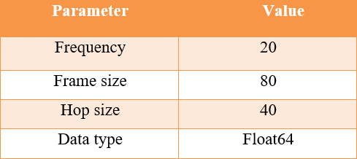

Activity Recognition Algorithm

HAR techniques include raw activity data standardization and preprocessing, as well as the use of DL algorithms to recognize human behaviors. The proposed recognition of activities algorithm performed as follows.

CNN for Human Activity Recognition

CNN, often known as ConvNet, is a DL approach that falls under the field of ANN. In the HAR domain, CNNs are extensively utilized supervised DL approaches to overcome the challenge of handcrafted feature extraction. CNN layers are employed to extract features from raw time-series data automatically, eliminating the need for human intervention. In audio and picture recognition, interactive gaming, and processing natural languages, CNN have proven remarkable prediction ability. They're also employed in recommendation algorithms [81], picture classification, the process of segmentation and analysis [82], and interfaces between brains and computers [83], and financial data series [84]. The CNN architecture consists of a data input layer, layers that are hidden, and a final output layer. The main components of a CNN structure that perform feature extraction are called convolution layers. Convolutional layers carry out dot product of the convolution kernel and hidden layers' input matrix. This dot product's activation process is referred to as ReLU.. The convolution operation produces a feature map. The Feature map, which displays image information such as corners and edges. When the convolution operation is applied to input and output is passed to the next layer by convolution layer in CNN. Following types of layers are pooling layers and fully connected layers. The pooling layers perform input feature map down sampling. Pooling layers reduce data dimensionality by combining the outputs of neuron clusters into a single neuron in succeeding layers, resulting in lower processing costs. While FC layers are

used for classification. Previous layers' filters and features are extracted by the FC layers, which then carry out classification. Softmax activation function is used in this type of layer to categorize inputs. Data must be reshaped for the input layer. A two-dimensional CNN's input and output data are both three-dimensional. As a result, accelerometer values are used as the three-dimensional input data for the proposed 2D CNN model. The accelerometer data is a time -series. Furthermore, due to the complete interconnection of its layers, CNN networks are prone to data overfitting. Weight decay, skipped connections, and dropout approaches can be used to regularize overfitting. We employed the dropout method when creating the two-dimensional CNN model to lessen overfitting. After the data has been pre-processed, each record (associated with each activity) is fed into the neural network. Convolution, pooling, and fully linked layers in the hidden layer, with Softmax activation at the top layer, perform the necessary action on the data once it has been reshaped.

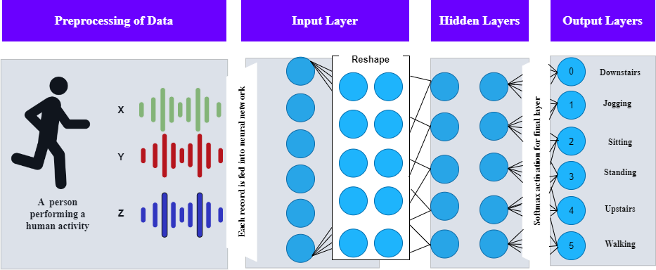

Figure 3-5 CNN model development

Now, as shown in Fig 3-5, we will discuss the model development process in detail. The person performs in one of the six activities. The sensors used, such the gyroscope and accelerometer, record data for the three axes. The recorded data must be reshaped before being sent into the neural network for preprocessing. This reconfiguration ensures that each individual has numerous 2D records, with 80 time slices for each of the three accelerometer data, as well as the labels that go with them. There are six unique labels and each label represents one of the human activities that have been discussed. After that, during training, the recordings are input into the neural network. The input layer is a 240-element vector produced by flattening the representation of 80 time slices with three accelerometer measurements each. There are three further hidden layers with 100 nodes each. The model's layers are all linked to one another. A Softmax activation layer is added at the end, as well as an additional layer that reshapes the input into an 80 x 3 matrix. Finally, Figure 1 depicts the six accessible labels in the output layer: 0, 1, 2, 3, 4, and 5. The network will provide the probability for each output class.

Chapter 4: Results and Discussion

This section describes the experimental setup and results. WISDM dataset is utilized, and pre-trained 2D CNN model are used for analysis. A comparative evaluation is performed between the results of this model and the previous methods for classifying HAR. The results presented in this study are obtained through the utilization of the suggested deep learning-based models.

Experimental Setup

The outcome is predicated on the data, it includes 3555 samples from the WISDM dataset representing six different daily life activities. The Python programing language was utilized to implement the experiment with the CNN model. Keras, a widely used Python library, in conjunction with TensorFlow, was the primary tool used in this study. The implementation platform chosen for this project was Jypyter Notebook. Continuing with the process, the model requires compilation and fitting. For this purpose, a mini-batch size of 80 samples is determined through experimental analysis.
Table 4-1 Experimental Setup
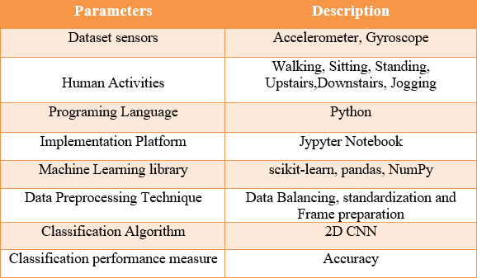

Performance Evaluation Metrics

Using the accuracy, recall, precision and F1 score measure, the effectiveness of the suggested model was quantitatively evaluated. In classification issues, the most common measure for algorithm performance is accuracy. This measurement is derived as follows:

True positive (TP) refers to the number of positive cases accurately identified by the classifier as being connected with specified human activities. The number of negative instances correctly identified by the classifier as not belonging to the target activity is called to as TN (true negative). The term "false positive" refers to the number of positive examples identified by the classifier as the activity of interest. The term FN refers to the number of negative examples that the classifier incorrectly labels as not belonging to the activity of interest.

Data Splitting

It is split into two independent sets: one for HAR model training and the other for performance evaluation. HAR model training is done using the training set, allowing it to learn patterns and relationships between features and activity labels. The data is divided, with 80% of available data

allocated for training and the remaining 20% allocated for testing. The effectiveness of model overall throughout training and validation may be evaluated with this method. Furthermore, for accelerometer measurements, each 2D record must contain 80 time segments; the data is rearranged as follows:

Table 4-2 Dataset before & after reshaping

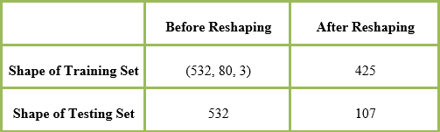

The following are the sample data dimensions: The total duration in slices (width) is 80, and the sample height (as determined by accelerometers on the three-dimensional axes) is 3.There are 425 samples obtained in the training set and 107 samples in the testing set. The objective of reshaped is to make sure that data fed into the model is in proper structure.

Proposed Approach

The proposed approach of 2D CNN model is described below:

The 2D CNN Model

Following the completion of the dataset preprocessing stages, the next step was to create a two-dimensional CNN. As illustrated in Fig. 4-1, the model is made up of several layers, including input data layer, convolution layer, pooling layer, fully connected layer, and output layer.

Sequential layer is the first layer in neural network that allows for the insertion of other layers. In this model, the size of the filter for the sequential layer is set to 16.

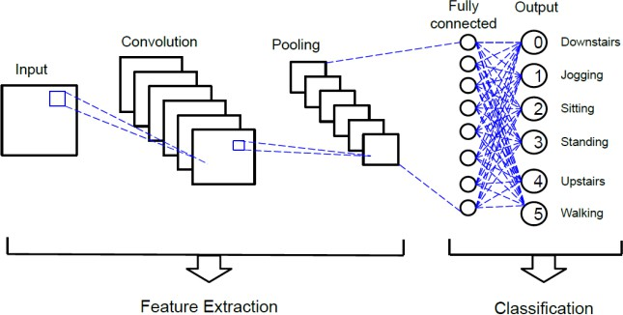

Figure 4-1 Different Layers of 2D CNN model

This layer also performs data reshaping, converting it back to its original format. This model includes six actions (upstairs, jogging, sitting, standing, downstairs, and walking). The following layer of convolution uses the ReLU as a universally applicable function of activation and has a filter size of 32. To reduce overfitting, the sequential layer has a dropout of 0.1 while the next three hidden layers have a dropout of 0.2. Following that, a dropout value of 0.5 is employed for dense layers. For the first four layers, the size of the Kernel is (2, 2), which means that the convolution to perform window's height and width are 2 and 2, respectively. The model’s configuration as shown in the table 4-3. The next step is to compile our model. Furthermore, the category cross entropy is represented by corresponding loss function. The experiment is carried out using the

ADAM optimizer. Table 4-4 displays the parameter values.

Table 4-3 Layer-wise configuration of proposed model

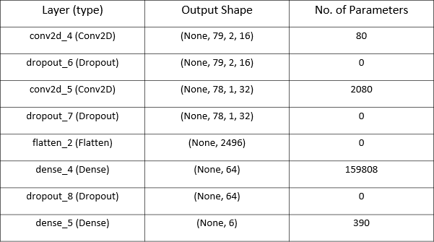

Table 4-4 Optimizer Parameters

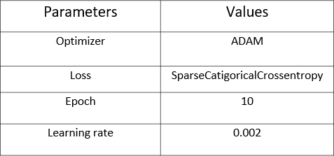

Results and Discussion

We concluded that the proposed 2D CNN approach predicted human behaviors quite accurately. The 2D CNN model recognized sitting and standing activities perfectly. Furthermore, activities like jogging, walking, and going downstairs were accurately anticipated. The upstairs activity, on the other hand, had the lowest accuracy since the model became incorrectly recognized with the downstairs activity due to their comparable nature. The average prediction accuracy for the six activities is 95%.

Table 4-5 Results of proposed model

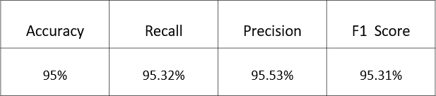

Model Evaluation

After the model is developed, we must evaluate our model to ensure that it is able to predict human activities. Two learning curves were plotted for this purpose, and the results are provided in this research. Figures 4-2 and 4-3 depict the training-validation loss and training-validation accuracy curves, respectively. Which shows that the CNN model was trained with great accuracy. Thus, neither overfitting nor underfitting of the proposed model is evident.

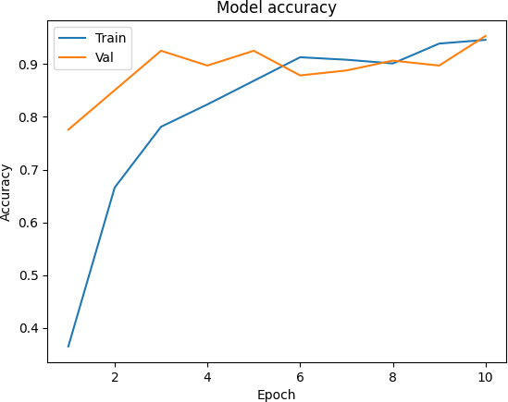

Figure 4-2 Graph illustrating model accuracy

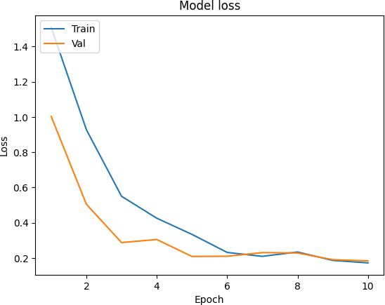

Figure 4-3 Model loss detection graph

Confusion Matrix

Using a confusion matrix, the six activities are finally predicted. Consequently, a 6x6 matrix is created with the diagonal squares representing the probabilities of recognition of each of the six classes after the test data are passed through an appropriate function.

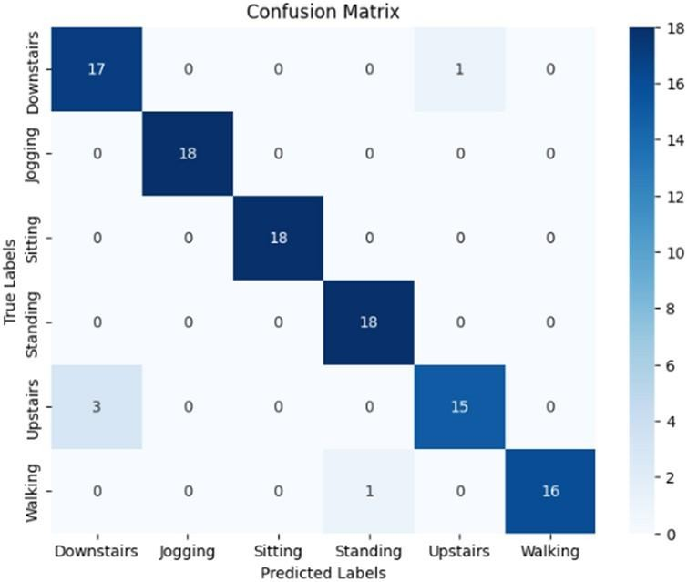

Figure 4-4 Confusion Matrix Evaluated by proposed model

Comparison of proposed approach with other Techniques

According to the literature, when more classification classes are added, the model's performance degrades. Because the model predicts for several classes, there is a greater chance that the prediction will be incorrect. And the model's error rate will be higher because it must predict for numerous classes. As a result, the classifier's performance generally decreases as the number of classification classes increases.
Table 4-6 contrasts our proposed 2D CNN model with previous methods applied to HAR-based issues using the comparative datasets provided. Based on a performance comparison of the proposed model and various existing approaches, we can definitely conclude that our strategy outperforms the ones listed below. In [54], To automatically extract and identify features from raw data, a 1D CNN was utilized. Through a deep learning algorithm, this study presented a device that can be worn capable of identifying six human daily actions and the data recorded. During the testing phase, the recognition rates were 95% and 93%, respectively. [53] Presents two ML models for classifying time-series data from observed subjects' smartwatch accelerometers. For classification, DNN and RF classifier methods are utilized. The Random Forest model achieved 75% accuracy in validation and recognition, while the deep neural network performed slightly better with an accuracy of 81%. By comparing recognition algorithms, this work [59] proposes a wearable device integrated with inertial and temperature sensors which is utilized to detect body surface temperature using HAR, allowing for body temperature monitoring and variations. The sensing device, which consists of an STM 32 microcontroller, a 6-axis sensor (accelerometer and gyroscope), and an ambient temperature sensor, collects raw data from 10 individual people across four different daily activity scenarios.

Following that, unprocessed data passes through several preprocessing techniques such signal homogeneity, data stacking, and reprocessing. The most accurate classifier, RF, has been shown to have a recognition accuracy of 88.78%. This study [67] aims to help the elderly by tracking their activities in in various environments both inside and out using gyroscope and accelerometer data from a smart phone. Traditional ML and DL approaches such as KNN, RF, SVM, ANN, and LSTM Network are used to recognize human behaviors. LSTM is a recurrent neural network version that handles temporal sequences well. Among all classification techniques examined, the suggested LSTM Network had the greatest accuracy of 95.04%. The SVM, on the other hand, achieved an accuracy of 89.07% with a relatively low computational time. [85] Suggests employing simple features of statistics that maintain information about the worldwide structure of time-series data in conjunction with CNN to perform local feature extraction. The accuracy rating using the manually handcrafted features is 90.42%.
In our purposed model, a detailed mechanism has been performed on the proposed dataset. Initially dataset was chosen based on multiple categories then the dataset was balanced utilizing balancing techniques so that overfitting and underfitting phenomenon can be minimized. The suggested approach proves to be efficient as it gave an accuracy of 95%. The novelty factor for this study is the balancing of a large dataset with multiple categories so that the problem for inaccurate classification can be minimized. The results showing 95% accuracy results are basically showing the accurate performance of the model trained on a balanced dataset.

Table 4-6 A comparison of our approach to other techniques
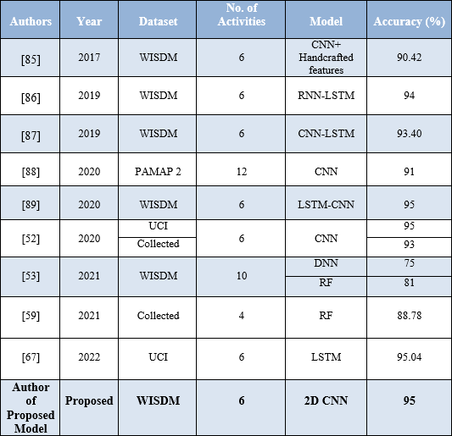

Chapter 5: Conclusion

As the risk of covid-19 virus infection has increased in recent years, managing their activity status has become more difficult. As a result of the virus's global spread, many people are either restricted to their homes or placed in designated locations due to quarantine restrictions. As the situation rises, HAR is required to monitor levels of physical activity, which acts as an indicator for measuring both physical and mental well-being. Using a 2D CNN model, this research paper effectively recognized and predicted Human Activities using a previous dataset based on accelerometer measurements. The proposed model properly predicts and identifies the majority of the six behaviors. Our findings illustrate the importance of developing a two-dimensional CNN and its specific applications in HAR. The proposed model was evaluated, and it showed a precision rate of 95% during the evaluation. The model's effectiveness is comparable to that of other state-of-the-art techniques. In the framework of this research, future studies will focus on improving classification accuracy and predicting outcomes. Another area of future research could be the prediction of abnormal human behaviors. A functional activity detection system can be used to monitor dependent people in smart homes, such as the elderly, and assess their activity level for healthcare services.

References:

- C. Jobanputra, J. Bavishi, and N. Doshi, “Human activity recognition: A survey,” Procedia Comput. Sci., vol. 155, no. 2018, pp. 698–703, 2019, doi: 10.1016/j.procs.2019.08.100.
- https://www.v7labs.com/blog/human-activity-recognition#applications-and-uses-of-human-
activity-recognition, 2023.
- Z. Hussain, M. Sheng, and W. E. Zhang, “Different Approaches for Human Activity Recognition: A Survey,” pp. 1–28, 2019, doi: 10.1016/j.jnca.2020.102738.
- Y. Zhao, H. Zhou, S. Lu, Y. Liu, X. An, and Q. Liu, “Human Activity Recognition Based on Non-Contact Radar Data and Improved PCA Method,” Appl. Sci., vol. 12, no. 14, 2022, doi: 10.3390/app12147124.
- Sun, L., et al. Activity recognition on an accelerometer embedded mobile phone with varying positions and orientations. in International conference on ubiquitous intelligence and computing. 2010. Springer.
- Qi, J., Yang, P., Hanneghan, M., Tang, S., & Zhou, B. (2018). A hybrid hierarchical framework for gym physical activity recognition and measurement using wearable sensors. IEEE Internet of Things Journal, 6(2), 1384-1393.
- Tosato, D., Spera, M., Cristani, M., & Murino, V. (2012). Characterizing humans on riemannian manifolds. IEEE Transactions on Pattern Analysis and Machine Intelligence, 35(8), 1972-1984.
- Hsu, Y. L., Yang, S. C., Chang, H. C., & Lai, H. C. (2018). Human daily and sport activity recognition using a wearable inertial sensor network. IEEE Access, 6, 31715-31728.
- Ramasamy Ramamurthy, S., & Roy, N. (2018). Recent trends in machine learning for human activity recognition—A survey. Wiley Interdisciplinary Reviews: Data Mining and Knowledge Discovery, 8(4), e1254.
- M. M. Islam, S. Nooruddin, F. Karray, and G. Muhammad, “Human activity recognition using tools of convolutional neural networks: A state of the art review, data sets, challenges, and future prospects,” Comput. Biol. Med., vol. 149, 2022, doi: 10.1016/j.compbiomed.2022.106060.
- World Health Organization. Coronavirus Disease 2019 (COVID-19): Situation Report, 51. 2020. Available online: https://www.who.int/docs/default-source/coronaviruse/situation-reports/20200311-sitrep-51-covid-19.pdf?sfvrsn=1ba62e57_10 (accessed on 22 Mar).
- Lee, I. M., Shiroma, E. J., Lobelo, F., Puska, P., Blair, S. N., & Katzmarzyk, P. T. (2012). Effect of physical inactivity on major non-communicable diseases worldwide: an analysis of burden of disease and life expectancy. The lancet, 380(9838), 219-229.
- M. O. Gani, “A Novel Approach to Complex Human Activity Recognition,” ProQuest Diss. Theses, p. 155, 2017, [Online]. Available: http://ezproxy.library.usyd.edu.au/login?url=https://search.proquest.com/docview/1896531143
?accountid=14757%0Ahttp://dd8gh5yx7k.search.serialssolutions.com?ctx_ver=Z39.88-

2004&ctx_enc=info:ofi/enc:UTF-8&rfr_id=info:sid/ProQuest+Dissertations+%26+Theses+Gl
- M. Vrigkas, C. Nikou, and I. A. Kakadiaris, “A review of human activity recognition methods,” Front. Robot. AI, vol. 2, no. NOV, pp. 1–28, 2015, doi: 10.3389/frobt.2015.00028.
- L. Chen, J. Hoey, C. D. Nugent, D. J. Cook, and Z. Yu, ‘Sensor_based activity recognition,’ IEEE Transactions on Systems, Man, and Cybernetics, Part C (Applications and Reviews), vol. 42, no. 6,
pp. 790–808, 2012.
- D. R. Seshadri et al., “Wearable sensors for monitoring the physiological and biochemical profile of the athlete,” npj Digit. Med., vol. 2, no. 1, 2019, doi: 10.1038/s41746-019-0150-9.
- S. Wang and G. Zhou, “A review on radio based activity recognition,” Digit. Commun. Networks, vol. 1, no. 1, pp. 20–29, 2015, doi: 10.1016/j.dcan.2015.02.006.
- UCI-HAR Acitivity recognition data set . Available online: https://archive.ics.uci.edu/ml/datasets/human+activity+recognition+using+smartphones.
- R. Nair, M. Ragab, O. A. Mujallid, K. A. Mohammad, R. F. Mansour, and G. K. Viju, “Impact of Wireless Sensor Data Mining with Hybrid Deep Learning for Human Activity Recognition,” Wirel. Commun. Mob. Comput., vol. 2022, 2022, doi: 10.1155/2022/9457536.
- OPPORTUNITY Activity Recognition Data Set. Available online: https://archive.ics.uci.edu/ml/datasets/opportunity+activity+recognition (accessed on 6 March 2018).
- PAMAP2 Physical Activity Monitoring Data Set. Available online: http://archive.ics.uci.edu/ml/datasets/pamap2+physical+activity+monitoring (accessed on 30 November 2017).
- J. Qi, P. Yang, A. Waraich, Z. Deng, Y. Zhao, and Y. Yang, “Examining sensor-based physical activity recognition and monitoring for healthcare using Internet of Things: A systematic review,” J. Biomed. Inform., vol. 87, no. March, pp. 138–153, 2018, doi: 10.1016/j.jbi.2018.09.002.
- A. Wang, G. Chen, J. Yang, S. Zhao and C. -Y. Chang, ‘A Comparative Study on Human Activity Recognition Using Inertial Sensors in a Smartphone,’ in IEEE Sensors Journal, vol. 16, no. 11, pp. 4566-4578, June1, 2016, doi: 10.1109/JSEN.2016.2545708.
- Harari, G. M., Lane, N. D., Wang, R., Crosier, B. S., Campbell, A. T., & Gosling, S. D. (2016). Using smartphones to collect behavioral data in psychological science: Opportunities, practical considerations, and challenges. Perspectives on Psychological S.
- Muralidharan, K., Khan, A. J., Misra, A., Balan, R. K., & Agarwal, S. (2014, February). Barometric phone sensors: More hype than hope!. In Proceedings of the 15th workshop on mobile computing systems and applications (pp. 1-6).
- M. Z. ur Rehman et al., “Multiday EMG-Based classification of hand motions with deep learning techniques,” Sensors (Switzerland), vol. 18, no. 8, pp. 1–16, 2018, doi: 10.3390/s18082497.
- Liu, J., Chen, J., Jiang, H., Jia, W., Lin, Q., & Wang, Z. (2018, May). Activity recognition in wearable ECG monitoring aided by accelerometer data. In 2018 IEEE international symposium on circuits and

systems (ISCAS) (pp. 1-4). IEEE.
- M. Shoaib, S. Bosch, O. Durmaz Incel, H. Scholten, and P. J. M. Havinga, Fusion of smartphone motion sensors for physical activity recognition, vol. 14, no. 6. 2014. doi: 10.3390/s140610146.
- D. Micucci, M. Mobilio, and P. Napoletano, “UniMiB SHAR: A dataset for human activity recognition using acceleration data from smartphones,” Appl. Sci., vol. 7, no. 10, 2017, doi: 10.3390/app7101101.
- A. Alruban, H. Alobaidi, N. Clarke, and F. Li, “Physical activity recognition by utilising smartphone sensor signals,” ICPRAM 2019 - Proc. 8th Int. Conf. Pattern Recognit. Appl. Methods, pp. 342–351, 2019, doi: 10.5220/0007271903420351.
- Su, X., Tong, H., & Ji, P. (2014). Activity recognition with smartphone sensors. Tsinghua science and technology, 19(3), 235-249.
- F. Cruciani et al., “A public domain dataset for human activity recognition in free-living conditions,” Proc. - 2019 IEEE SmartWorld, Ubiquitous Intell. Comput. Adv. Trust. Comput. Scalable Comput. Commun. Internet People Smart City Innov. SmartWorld/UIC/ATC/SCALCOM/IOP/SCI 2019, no. April, pp. 166–171, 2019, doi: 10.1109/SmartWorld-UIC-ATC-SCALCOM-IOP-SCI.2019.00071.
- Data preprocessing in detail(June 14, 2019) from S. Mushtaq, https://developer.ibm.com/articles/data-preprocessing-in-detail/.
- Data Preprocessinng in Data Minning- A Hands on guide(April 26, 2023) from https://www.analyticsvidhya.com/blog/2021/08/data-preprocessing-in-data-mining-a-hands-on-guide/.
- K. T. Nguyen, F. Portet, and C. Garbay, “Dealing with Imbalanced Data Sets for Human Activity Recognition Using Mobile Phone Sensors,” Intell. Environ. 2018, vol. 23, pp. 129–138, 2018, [Online]. Available: https://hal.archives-ouvertes.fr/hal-01950472/
- Vaizman, Y., Ellis, K., & Lanckriet, G. (2017). Recognizing detailed human context in the wild from smartphones and smartwatches. IEEE pervasive computing, 16(4), 62-74.
- N. Yala, B. Fergani, and A. Fleury, “Feature extraction for human activity recognition on streaming data,” INISTA 2015 - 2015 Int. Symp. Innov. Intell. Syst. Appl. Proc., 2015, doi: 10.1109/INISTA.2015.7276759.
- O. Banos, J. M. Galvez, M. Damas, H. Pomares, and I. Rojas, “Window size impact in human activity recognition,” Sensors (Switzerland), vol. 14, no. 4, pp. 6474–6499, 2014, doi: 10.3390/s140406474.
- Feature extraction for machine learning and deep learning. from https://www.mathworks.com/discovery/featureextraction.html#:~:text=Feature%20extraction% 20for%20machine%20learning,directly%20to%2 0the%20raw%20data.
- A. Ferrari, D. Micucci, M. Mobilio and P. Napoletano, ‘Hand-crafted Features vs Residual Networks for Human Activities Recognition using Accelerometer,’ 2019 IEEE 23rd International Symposium on Consumer Technologies (ISCT), Ancona, Italy, 2019, pp. 153-1.

- Clustering vs. Classification in AI: How Are They Different? from https://lucidworks.com/videos/clustering-vs-classification-in-ai-how-are-they-different/.
- Top 6 Machine Learning Algorithms for Classification. from https://towardsdatascience.com/top-machine-learning-algorithms-for-classification-2197870ff501.
- Classification in Machine Learning: What it is and Classification Models. (Jun 3, 2022). from https://www.simplilearn.com/tutorials/machine-learning-tutorial/classification-in-machine-learning.
- R. Jansi and R. Amutha, “Sparse representation based classification scheme for human activity recognition using smartphones,” Multimed. Tools Appl., vol. 78, no. 8, pp. 11027–11045, 2019, doi: 10.1007/s11042-018-6662-5.
- N. Ahmed, J. I. Rafiq, and M. R. Islam, “Enhanced human activity recognition based on smartphone sensor data using hybrid feature selection model,” Sensors (Switzerland), vol. 20, no. 1, 2020, doi: 10.3390/s20010317.
- Navita and P. Mittal, “Machine Learning (ML) based Human Activity Recognition Model using Smart Sensors in IoT Environment,” Proc. Conflu. 2022 - 12th Int. Conf. Cloud Comput. Data Sci. Eng., no. Ml, pp. 330–334, 2022, doi: 10.1109/Confluence52989.2022.9734152.
- B. Vidya and S. P, “Wearable multi-sensor data fusion approach for human activity recognition using machine learning algorithms,” Sensors Actuators A Phys., vol. 341, no. March, p. 113557, 2022, doi: 10.1016/j.sna.2022.113557.
- R. Khan, M. Abbas, R. Anjum, F. Waheed, S. Ahmed and F. Bangash, ‘Evaluating Machine Learning Techniques on Human Activity Recognition Using Accelerometer Data,’ 2020 International Conference on UK-China Emerging Technologies (UCET), Glasgow, UK, 2020, pp.
- N. Y. Hammerla, S. Halloran, and T. Plötz, “Deep, convolutional, and recurrent models for human activity recognition using wearables,” IJCAI Int. Jt. Conf. Artif. Intell., vol. 2016-Janua, pp. 1533–1540, 2016.
- Top 10 Deep Learning Algorithms You Should Know in 2022. (Feb 16, 2023). from https://www.simplilearn.com/tutorials/deep-learning-tutorial/deep-learning-algorithm.
- T. Zebin, P. J. Scully, N. Peek, A. J. Casson, and K. B. Ozanyan, “Design and Implementation of a Convolutional Neural Network on an Edge Computing Smartphone for Human Activity Recognition,” IEEE Access, vol. 7, pp. 133509–133520, 2019, doi: 10.1109/ACCESS.2019.2941836.
- C. T. Yen, J. X. Liao, and Y. K. Huang, “Human daily activity recognition performed using wearable inertial sensors combined with deep learning algorithms,” IEEE Access, vol. 8, pp. 174105–174114, 2020, doi: 10.1109/ACCESS.2020.3025938.
- D. S. Radivojević, N. S. Mirkov, and S. Maletić, “Human Activity Recognition based on Machine Learning Classification of Smartwatch Accelerometer Dataset,” FME Trans., vol. 49, no. 1, pp. 225–232, 2020, doi: 10.5937/FME2101225R.
- H. Activity, S. Homes, and S. Mekruksavanich, “LSTM Networks Using Smartphone Data for Sensor-Based,” pp. 1–25, 2021.

- V. Ghate and C. Sweetlin Hemalatha, “Hybrid deep learning approaches for smartphone sensor-based human activity recognition,” Multimed. Tools Appl., vol. 80, no. 28–29, pp. 35585–35604, 2021, doi: 10.1007/s11042-020-10478-4.
- D. Ravi, C. Wong, B. Lo, and G. Z. Yang, “A Deep Learning Approach to on-Node Sensor Data Analytics for Mobile or Wearable Devices,” IEEE J. Biomed. Heal. Informatics, vol. 21, no. 1, pp. 56–64, 2017, doi: 10.1109/JBHI.2016.2633287.
- Bevilacqua, A., MacDonald, K., Rangarej, A., Widjaya, V., Caulfield, B., & Kechadi, T. (2019). Human activity recognition with convolutional neural networks. In Machine Learning and Knowledge Discovery in Databases: European Conference, ECML PKDD 2018, Du.
- O. Nafea, W. Abdul, G. Muhammad, and M. Alsulaiman, “Sensor-based human activity recognition with spatio-temporal deep learning,” Sensors, vol. 21, no. 6, pp. 1–20, 2021, doi: 10.3390/s21062141.
- L. Zhang, Y. Zhu, M. Jiang, Y. Wu, K. Deng, and Q. Ni, “Body temperature monitoring for regular covid-19 prevention based on human daily activity recognition,” Sensors, vol. 21, no. 22, pp. 1–19, 2021, doi: 10.3390/s21227540.
- S. K. Challa, A. Kumar, and V. B. Semwal, “A multibranch CNN-BiLSTM model for human activity recognition using wearable sensor data,” Vis. Comput., vol. 38, no. 12, pp. 4095–4109, 2022, doi: 10.1007/s00371-021-02283-3.
- D. Thakur, S. Biswas, E. S. L. Ho, and S. Chattopadhyay, “ConvAE-LSTM: Convolutional Autoencoder Long Short-Term Memory Network for Smartphone-Based Human Activity Recognition,” IEEE Access, vol. 10, pp. 4137–4156, 2022, doi: 10.1109/ACCESS.2022.3140373.
- T. H. Tan, J. Y. Wu, S. H. Liu, and M. Gochoo, “Human Activity Recognition Using an Ensemble Learning Algorithm with Smartphone Sensor Data,” Electron., vol. 11, no. 3, pp. 1–17, 2022, doi: 10.3390/electronics11030322.
- N. A. Choudhury, S. Moulik, and D. S. Roy, “Physique-Based Human Activity Recognition Using Ensemble Learning and Smartphone Sensors,” IEEE Sens. J., vol. 21, no. 15, pp. 16852–16860, 2021, doi: 10.1109/JSEN.2021.3077563.
- Y. J. Luwe, C. P. Lee, and K. M. Lim, “Wearable Sensor-Based Human Activity Recognition with Hybrid Deep Learning Model,” Informatics, vol. 9, no. 3, 2022, doi: 10.3390/informatics9030056.
- N. Varshney, B. Bakariya, A. K. S. Kushwaha, and M. Khare, “Human activity recognition by combining external features with accelerometer sensor data using deep learning network model,” Multimed. Tools Appl., vol. 81, no. 24, pp. 34633–34652, 2022, doi: 10.1007/s11042-021-11313-0.
- Prabono, A. G., Yahya, B. N., & Lee, S. L. (2021). Atypical sample regularizer autoencoder for cross-domain human activity recognition. Information Systems Frontiers, 23, 71-80.
- A. Hayat, M. D. Fernando, B. P. Bhuyan, and R. Tomar, “Human Activity Recognition for Elderly People Using Machine and Deep Learning Approaches,” Inf., vol. 13, no. 6, pp. 1–13, 2022, doi: 10.3390/info13060275.
- D. Bhattacharya, D. Sharma, W. Kim, M. F. Ijaz, and P. K. Singh, “Ensem-HAR: An Ensemble Deep

Learning Model for Smartphone Sensor-Based Human Activity Recognition for Measurement of Elderly Health Monitoring,” Biosensors, vol. 12, no. 6, 2022, doi: 10.3390/bios12060393.
- D. Thakur and S. Biswas, “An Integration of feature extraction and Guided Regularized Random Forest feature selection for Smartphone based Human Activity Recognition,” J. Netw. Comput. Appl., vol. 204, no. October 2021, p. 103417, 2022, doi: 10.1016/j.jnca.2022.103417.
- S. Mekruksavanich and A. Jitpattanakul, CNN-Based Deep Learning Network for Human Activity Recognition During Physical Exercise from Accelerometer and Photoplethysmographic Sensors, vol.
117. Springer Nature Singapore, 2022. doi: 10.1007/978-981-19-0898-9_42.
- M. N. Meqdad, A. H. Hussein, S. O. Husain, A. M. Jawad, and S. Kadry, “Human activity recognition method using joint deep learning and acceleration signal,” IAES Int. J. Artif. Intell., vol. 12, no. 3,
pp. 1459–1467, 2023, doi: 10.11591/ijai.v12.i3.pp1459-1467.
- E. Hysenllari, J. Ottenbacher, and D. McLennan, “Validation of human activity recognition using a convolutional neural network on accelerometer and gyroscope data,” Ger. J. Exerc. Sport Res., vol. 52, no. 2, pp. 248–252, 2022, doi: 10.1007/s12662-022-00817-y.
- N. Dua, S. N. Singh, V. B. Semwal, and S. K. Challa, “Inception inspired CNN-GRU hybrid network for human activity recognition,” Multimed. Tools Appl., vol. 82, no. 4, pp. 5369–5403, 2023, doi: 10.1007/s11042-021-11885-x.
- S. Ward, S. Hu, and M. Zecca, “Effect of Equipment on the Accuracy of Accelerometer-Based Human Activity Recognition in Extreme Environments,” Sensors, vol. 23, no. 3, 2023, doi: 10.3390/s23031416.
- M. A. Khatun et al., “Deep CNN-LSTM With Self-Attention Model for Human Activity Recognition Using Wearable Sensor,” IEEE J. Transl. Eng. Heal. Med., vol. 10, no. May, pp. 1–16, 2022, doi: 10.1109/JTEHM.2022.3177710.
- T. H. Tan, J. Y. Shih, S. H. Liu, M. Alkhaleefah, Y. L. Chang, and M. Gochoo, “Using a Hybrid Neural Network and a Regularized Extreme Learning Machine for Human Activity Recognition with Smartphone and Smartwatch,” Sensors (Basel)., vol. 23, no. 6, 2023, doi: 10.3390/s23063354.
- D. Garcia-Gonzalez, D. Rivero, E. Fernandez-Blanco, and M. R. Luaces, “New machine learning approaches for real-life human activity recognition using smartphone sensor-based data,” Knowledge-Based Syst., vol. 262, p. 110260, 2023, doi: 10.1016/j.knosys.2023.110260.
- Soni, V., Jaiswal, S., Semwal, V. B., Roy, B., Choubey, D. K., & Mallick, D. K. (2023, January). An Enhanced Deep Learning Approach for Smartphone-Based Human Activity Recognition in IoHT. In Machine Learning, Image Processing, Network Security and Data S.
- V. Soni, H. Yadav, V. B. Semwal, B. Roy, D. K. Choubey, and D. K. Mallick, “A Novel Smartphone-Based Human Activity Recognition Using Deep Learning in Health care,” Lect. Notes Electr. Eng., vol. 946, pp. 493–503, 2023, doi: 10.1007/978-981-19-5868-7_36.

- Roelofs, R.; Fridovich-Keil, S.; Miller, J.; Shankar, V.; Hardt, M.; Recht, B.; Schmidt, L. A Meta-Analysis of Overfitting in Machine Learning. Available online:

https://www.kaggle.com/kaggle/meta-kaggle.
- Van Den Oord, A.; Dieleman, S.; Schrauwen, B. Deep content-based music recommendation. In Neural Information Processing Systems Conference; Neural Information Processing Systems Foundation: Vancouver, Canada, 2013.
- Collobert, R., & Weston, J. (2008, July). A unified architecture for natural language processing: Deep neural networks with multitask learning. In Proceedings of the 25th international conference on Machine learning (pp. 160-167).
- Avilov, O., Rimbert, S., Popov, A., & Bougrain, L. (2020, July). Deep learning techniques to improve intraoperative awareness detection from electroencephalographic signals. In 2020 42nd Annual International Conference of the IEEE Engineering in Medicine, IEEE Access, pp. 142–145.
- Avraam Tsantekidis; Nikolaos Passalis; Anastasios Tefas; Juho Kanniainen; Moncef Gabbouj, “Forecasting stock prices from the limit order book using convolutional neural networks,” IEEE, vol. 1, pp. 7–12, 2017.
- A. Ignatov, “Real-time human activity recognition from accelerometer data using Convolutional Neural Networks,” Elsevier, vol. 62, pp. 915–922, 2018.
- Pienaar, S. W., & Malekian, R. (2019, August). Human activity recognition using LSTM-RNN deep neural network architecture. In 2019 IEEE 2nd wireless africa conference (WAC) (pp. 1-5). IEEE.
- S. Deep and X. Zheng, ‘“Hybrid model featuring CNN and LSTM archi_tecture for human activity recognition on smartphone sensor data,”’ in Proc. 20th Int. Conf. Parallel Distrib. Comput., Appl. Technol. (PDCAT), Dec. 2019, pp. 259–264., IEEE.
- Wan, S., Qi, L., Xu, X., Tong, C., & Gu, Z. (2020). Deep learning models for real-time human activity recognition with smartphones. Mobile Networks and Applications, 25, 743-755.
- Xia, K., Huang, J., & Wang, H. (2020). LSTM-CNN architecture for human activity recognition. IEEE Access, 8, 56855-56866.

